Riding in Brisbane

Getting you home quicker and safer.

Information and inspiration for your next bike ride.

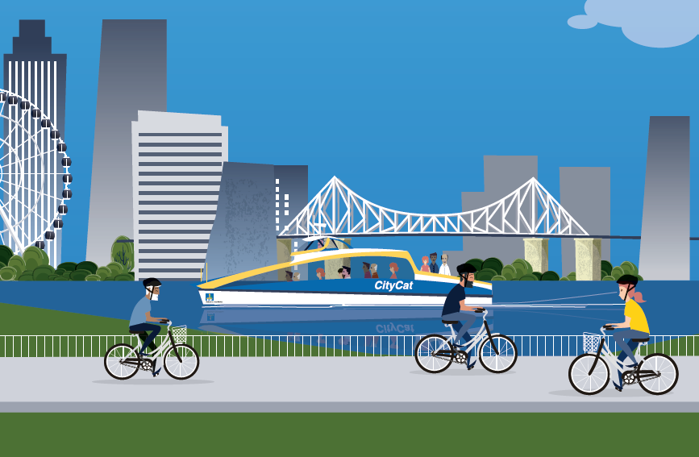

Contents

Let’s get riding 4
Reasons to ride 8
Riding safely 10
Kids and riding 18
Mountain biking and BMX riding 21
Getting around Brisbane by bike 24
Brisbane’s bikeways 28
Brisbane bikeway maps 31
Cycling Brisbane deals and discounts 56

Disclaimer
The material contained in this guide has been researched, assembled and included with all due care. Information contained in this guide is correct at the time of printing. Brisbane City Council should not be held responsible or liable for any losses, damages, charges and/or expenses incurred or sustained by any party relying on the material contained, incorporated or included in this guide. All editorial, maps and photographs appearing in this guide are strictly protected by copyright.

For more information, visit cyclingbrisbane.com.au or call Council on 3403 8888.

Welcome from Deputy Mayor
Krista Adams

With our city growing every day, Brisbane City Council is committed to encouraging more people to use public and active transport more often to get around quicker and safer.

From 2012-2016, Council invested $120 million to upgrade Brisbane’s bikeway network and is investing a further $100 million from 2016-2020 through its Better Bikeways 4 Brisbane program.

Council’s Cycling Brisbane initiative encourages people of all ages and abilities to ride a bike more or to simply give it a go. Since launching in March 2014, more than 21,000 people have joined the free program and enjoyed the exclusive membership benefits.

There are so many great reasons to ride a bike, and with CityCycle available around our city, you don’t even need to own a bike to go riding!

I encourage you to experience our safe, vibrant and green city by bike and I look forward to seeing you out and about on Brisbane’s extensive and growing bikeway network.

Cr Krista Adams
Deputy Mayor
Chair, Public and Active Transport, and Economic Development Committee
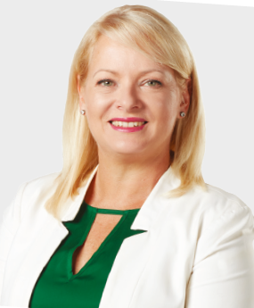

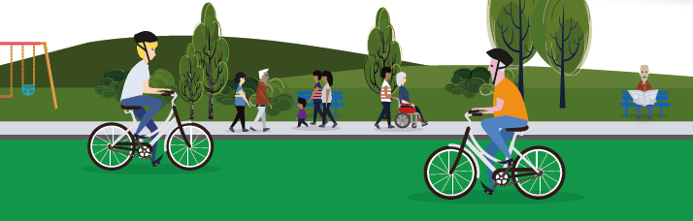

Let’s get riding

Cycling Brisbane is Brisbane City Council’s free membership program that aims to make it easier for everyone to choose to ride a bike in this city.

We promote what is great about riding and provide support to help people enjoy Brisbane by bicycle. The program also shares simple ways that riding a bike can become part of people’s everyday life, such as riding to school, shops, public transport, higher education or work.

Cycling Brisbane’s free membership includes:
- a monthly e-newsletter with the latest bikeway news and events in your local area

- access to a wide range of free bike skills workshops

- member discounts, including access to deals on bikes, accessories, repairs and more.

Stay in touch via Instagram @cyclingbrisbane and #cyclingbne

Join more than 21,000 people who have already signed up to Cycling Brisbane for free at cyclingbrisbane.com.au
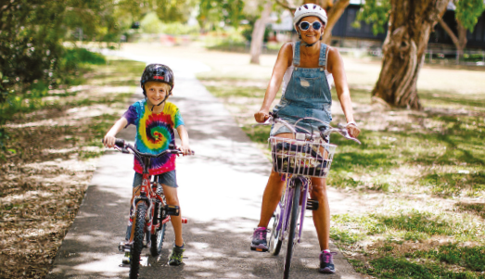

What’s happening to make bike riding better in Brisbane?

Brisbane has an extensive and growing network of bikeways.

Through the Better Bikeways 4 Brisbane program, Council is investing $100 million between 2016 and 2020 on bikeways to improve access to local destinations and the city centre. The signature bikeway projects include:

- the Woolloongabba Bikeway, which provides a safer environment for bike riders in both directions on Stanley Street and Annerley Road

- the Kangaroo Point Bikeway upgrade, linking South Bank to the Veloway 1 Bikeway and suburbs to the south east

- the Indooroopilly Riverwalk, a separated bikeway along the Brisbane River to link the Western Freeway with Indooroopilly and The University of Queensland at St Lucia

- the Botanic Gardens Riverwalk, which will improve access to the City Botanic Gardens along the Brisbane River

- construction of the North Brisbane Bikeway, from the city centre to Chermside, in partnership with the Queensland Government.

Council has completed the Kingsford Smith Drive River Walk, an off-road shared path beside the Brisbane River between Breakfast Creek and Bretts Wharf at Hamilton.

Council is also installing lighting on additional key bike routes around the city, as well as wayfinding signage and bicycle parking.

Making riding on the roads safer is also a priority. A key outcome of Council’s Citywide Pedestrian Safety Review and Move Safe Brisbane community consultation includes reducing the speed limit on some suburban and city centre roads.
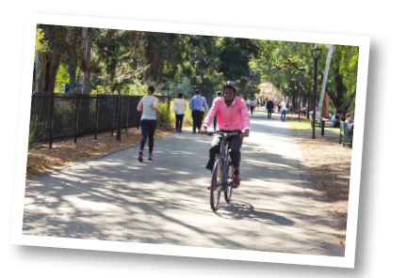

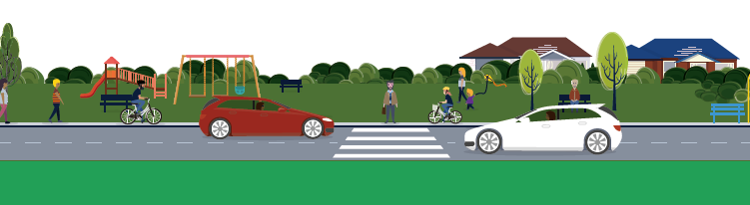

Free workshops

Cycling Brisbane runs plenty of free bike skills workshops as part of Council’s Active and Healthy program, with a range of options available.

- Children: kids can learn to transition from training wheels to two wheels and develop skills to have fun off-road and on bikeways.

- Electric bike tasters: try out a pedal-assisted electric bike.

- Riding on the road: learn tips and techniques for riding on the road.

- Refresher riding: build your skills and knowledge to regain confidence to start riding regularly again.

- Mountain biking: from basic skills to trail obstacles for beginner, intermediate and advanced levels.

- Maintaining a bike: learning to change a tyre and keep your bike in good condition.

Participants love our workshops and our accredited trainers. Here’s what they have to say:

“Such a fabulous workshop. I am not exaggerating when I say that it was a life changer.”

“Thank you so much. I am now riding to work one day per week and hope to increase to two days per week.”

“My daughter went from refusing to get on her bike at all to riding by herself.”

“As someone in his 50s looking to get more active and learn a new hobby, this was a great introduction. Thank you.”

Learn more about our expert, friendly trainers and the range of workshops we offer at cyclingbrisbane.com.au/events

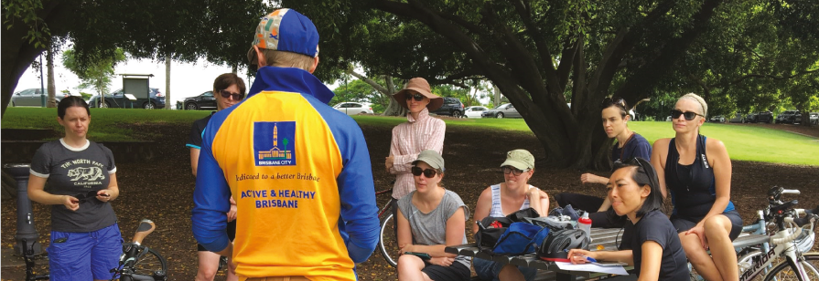

Where to buy a bike

Cycling Brisbane members have access to discounts on bikes and bike accessories from selected local businesses. See the back of this guide for a list of offers.

If you’re looking for a cheap bike, Council’s tip shops sell second-hand bikes that have been salvaged from landfill. For locations and opening hours, visit brisbane.qld.gov.au and search ‘tip shops’.

Some children with disabilities may find it difficult to balance or operate a bike. Brisbane-based not-for-profit Technology for Ageing Disability Queensland runs Freedom Wheels, which adapts standard bikes for kids with disabilities so they can experience the thrill of riding.
Visit tadq.org.au for more information.

No bike? No problem! You can hire a CityCycle for as little as $2 a day or $3 a month, Find out more at citycycle.com.au

Love to Ride Brisbane encourages everyone to ride for a minimum of 10 minutes in September. It’s fun, free and you could win some great prizes. Find out more at lovetoride.net/brisbane
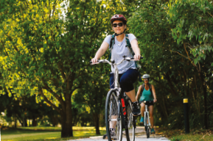

Katie’s story

Being a one-car family that is busy with five children, I wanted to find an easier and more convenient way to get to work. I hadn’t used a bike in more than 15 years so when I started, I could barely ride around the block without wobbling or crashing. My eight-year-old daughter had to tell me how to use gears as I had never been riding with them before!

By riding to work, I get to spend more time with my children. At most, my riding commute takes 30 minutes. Last week when my husband drove me to work, it took us 45 minutes.

I love the freedom that the bikeway gives me. I also love the environment I ride through, past the Kangaroo Point Cliffs and along the river. I enjoy the ride and time between finishing work and getting home.

My family and I also ride to school and around our local area. On the weekend or during the school holidays, we enjoy family rides to South Bank now that our youngest child is five years old and has the ability to make it there.
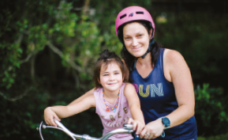

Reasons to ride

Riding a bike saves you money

Riding a bike doesn’t only keep you healthy, it also keeps more money in your pocket. You can save hundreds of dollars by riding instead of driving.

Average weekly costs

Bike - $16 per week
Small car - $159 per week
Large car - $233 per week

Notes: Figures are based on a five year average. Bike running costs calculated by Bicycle Queensland. Vehicle running costs sourced from RACQ’s Private Vehicle Expenses 2018. Excludes parking costs.

Riding a bike reduces congestion, and helps to keep everyone moving

On average, one car in Brisbane only carries 1.1 people, but takes up the same space as five people riding a bike.
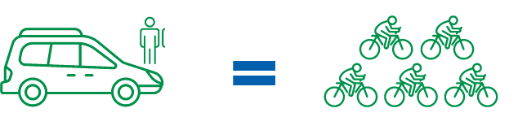

Notes: Average occupancy data sourced from 2016 Census published by Australian Bureau of Statistics. Space calculation taken from Walking and Cycling: The Economic Benefits published by Transport for London (2018)

Commuting by bike is good for your health

Riding to work can almost halve your risk of developing heart disease (46% lower) and cancer (45% lower) compared with driving a car. No wonder the number of people riding to work doubled in Brisbane between 2006 and 2016!
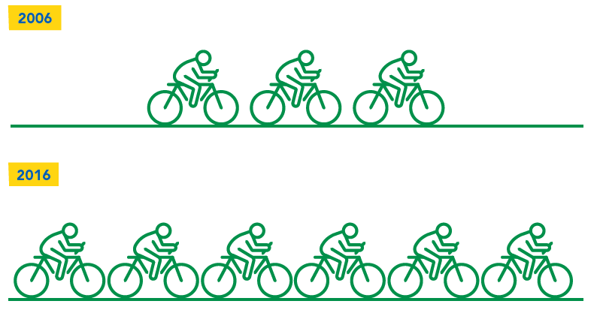

Notes: Health statistics drawn from research published in the British Medical Journal: Celis-Morales, C. et. al. (2017) ‘Association between active commuting and incident cardiovascular disease, cancer, and mortality: prospective cohort study.’

Journey to work data sourced from 2016 Census published by the Australian Bureau of Statistics.

You keep riding – we’ll keep counting!

Council’s real-time bikeway counters show how many people ride a bike past the counter each day. Did you know that in 2018, approximately 1.3 million riders passed the Bicentennial Bikeway counter at Milton?

To find out where bikeway counters are located, visit cyclingbrisbane.com.au/bikeways

Riding safely

Wherever you ride, you will be sharing the space with other people. Always ride at a safe speed and consider other people using the road, bikeway or footpath.

Remember that in Queensland, you are required to wear a helmet when riding a bike. You also need to:

- keep at least one hand on the handlebars

- use a front and back light at night

- have a bell fitted to your bike.

Discounts on helmets, lights and bells are available to Cycling Brisbane members. See the back of this guide for offers.

Riding on footpaths and shared pathways

You can ride on the footpath in Queensland unless there are signs or markings stating otherwise. People walking have priority, so be sure to give them space and travel at a speed that will allow you stop and avoid collisions. Be aware that other people on these paths may be distracted or involved in other activities.

You should ring your bell to make other people aware of your approach. There’s no need to ring your bell repeatedly as this may alarm some people and cause them to suddenly change direction.

Ride carefully behind and around other people who are using the path. This includes people who are riding slower than you or those on e-scooters or skateboards.

Report bikeway hazards at brisbane.qld.gov.au/about-council, or phone 3403 8888.

Watch Cycling Brisbane’s animation on sharing paths and roads at cyclingbrisbane.com.au/your-safety

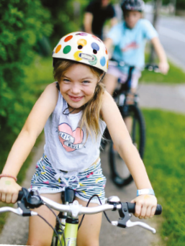

Creating safer streets for everyone

Council is increasing safety for people riding on the road through new on-road bikeways to create a dedicated space for riders. People riding a bike will be separated from people driving motor vehicles through a physical separator. Sometimes these separated spaces will be two-way on one side of the road so that people on bikes can travel in both directions.

Council’s Woolloongabba Bikeway includes a separated two-way section along parts of Stanley Street and Annerley Road. It will provide a safe connecting route and convenient access to businesses and facilities along the bikeway and surrounding areas.

Council is also introducing ‘green streets’, which are designed to prioritise bike riding and other active transport, while also permitting motor vehicles to use the space. Features of a green street include creating a low-speed environment by reducing the posted speed limit (preferably less than 40km/h) and through design elements such as building out kerbs and installing planter boxes.

The Kangaroo Point Bikeway upgrade includes the conversion of Little Dock Street to a green street.

For more information, visit brisbane.qld.gov.au and search ‘Woolloongabba Bikeway’

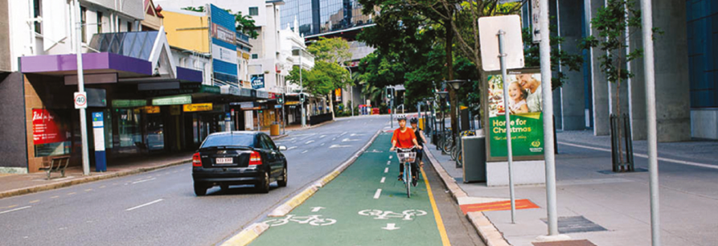

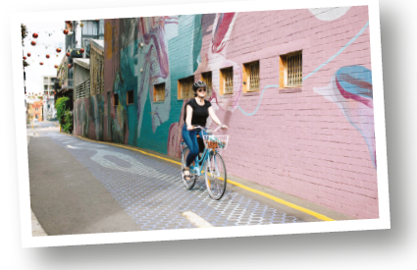

Riding signs and rules

Here are some of the signs and markings you may encounter on your bike trip.

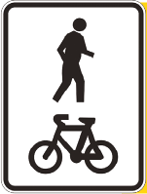
Shared pathway
Bike riders keep left and people walking are not to block the path. As an early warning to people walking or running, you should sound your bell early and slow down when overtaking. People on skateboards, roller blades, e-scooters and e-bikes are permitted to use shared pathways.

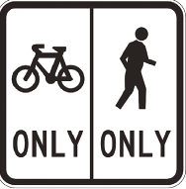
Separated pathway
On a separated path, ride on the side that is for bike riders and people on skateboards, roller blades, e-scooters and e-bikes. The other side is for people walking.

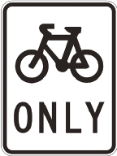

Bike-only pathway
Only people riding bikes and other personal mobility devices such as
e-scooters are permitted to use these paths. People are not allowed to walk on these paths.

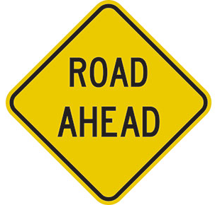

Road ahead
The bikeway crosses a road ahead and bike riders need to give
way to people who are driving.

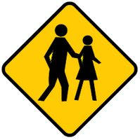
Pedestrian crossing ahead
This warning sign indicates that people are likely to be crossing the bike path ahead.

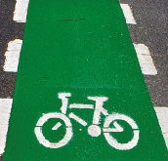
On-road bike lanes
Bike lanes are dedicated on-road cycling facilities. It is not
compulsory to ride in on-road bike lanes. People on e-scooters and
other personal mobility devices are not permitted to use these
on-road lanes.

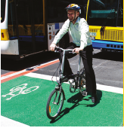
Bike boxes
Bike boxes are marked sections of road for bike riders to wait at a red light in front of vehicles. They are designed to improve safety by increasing visibility of bike riders to motorists.

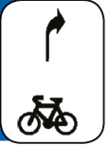
Hook turn storage box
A hook turn storage box is an area marked on the road at a multi-lane signalized intersection showing where to position yourself to do a ‘hook turn’ on your bike.

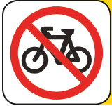
No bicycles
Riding is not permitted beyond this point. You must dismount and walk with your bike.

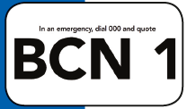
Bikeway emergency
The reference code on these signs will help you communicate your location to emergency services, so they can’t reach you via the most direct route.

Riding on the road

When riding on the road, you must obey the general road rules as well as the specific road rules for bike riders.

You can ride on the road and in bike, bus and transit lanes. You can choose to ride in a bike lane where one is provided but you don’t have to. Bike riders can ride two abreast but must stay within 1.5 metres of each other.

When riding on the road, you can help communicate safely with other road users by being:

- aware: ride cautiously and be aware of hat other road users are doing

- predictable: ride in a straight line and avoid weaving in and out of traffic or around parked cars

- seen: position yourself so that other road users can see you. Maintain at least a car door’s width between you and parked vehicles to avoid being hit by someone if they fail to look before opening their door.

To learn skills and tips for riding on the road, register for one of Cycling Brisbane’s
‘Get There By Bike’ workshops at cyclingbrisbane.com.au/events

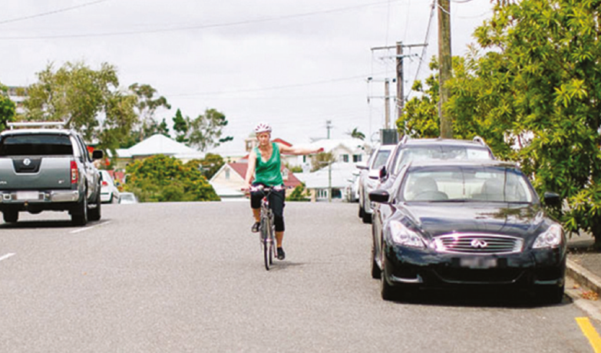

Sharing the road

Sharing road space when driving a vehicle

Many people who ride a bike also drive a car. Courteous and cautious driving can make a big difference to helping create a safer road environment for people riding bikes.

One metre matters
In Queensland, it is compulsory for people driving a car to stay at least:

- one metre away when passing a bike rider in a 60km/h or lower speed zone

- 1.5 metres where the speed limit is more than 60km/h.

The minimum passing distance applies when you want to go around two people on bikes who are riding beside each other.

Keep our streets safe for everyone and remember that one metre matters.

Think bike

As well as observing the one metre and 1.5 metre laws, there are some basic rules and tips to remember when sharing roads with people riding bikes.

- If you want to turn left and someone riding a bike is ahead of you, wait until they have passed the crossing before turning. Overtaking and cutting off someone riding a bike is very dangerous.

- If it is safe, you can go around a person on a bike provided you observe the minimum passing distance.

- Indicate right before going around a person riding a bike, and indicate left once you have passed them and are returning to your original position on the road.

- Check both ways when coming out of a side street and crossing a two-way bikeway.

- When opening a car door from the driver’s seat, use your left hand. This will to force you to look over your shoulder to check for people who might be riding past on a bike (this is called the ‘Dutch Reach’).

For more information on sharing the roads with people riding bikes, including an online quiz, visit streetsmarts.initiatives.qld.gov.au and click on ‘bicycle riders’
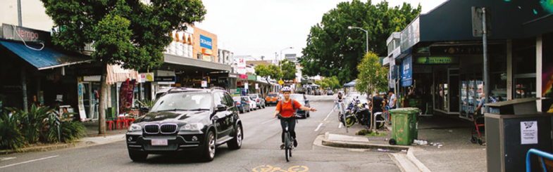

Look after you and your bike

Getting insured

Whether you’re a beginner or an experienced rider, accidents can happen so it’s important to be covered for any scenario. A Bicycle Queensland membership automatically provides insurance benefits for riders. See opposite page for more information.

Fixing your bike

Riding a well-serviced bike will also help to keep you safe. Check out the discounts on servicing and repairs available for Cycling Brisbane members at the back of this guide. Some mechanics will even come to your door!

Cycling Brisbane runs free, regular workshops on how to maintain your bike.
Book your place at cyclinbrisbane.com.au/events

The following is a list of community repair stations with basic tools for repairs such as fixing a puncture.

- River Quay Green, South Bank

- Clem Jones Promenade (near the Wheel of Brisbane), South Brisbane

- 10 Little Stanley Street, South Brisbane

- Riverside Drive Park (at intersection with Victoria Street), West End

- Banyan Lawn, Roma Street Parkland

- Multiple locations at University of Queensland campus, St Lucia.

For repair station locations, visit cyclingbrisbane.com.au/bike-maintenance

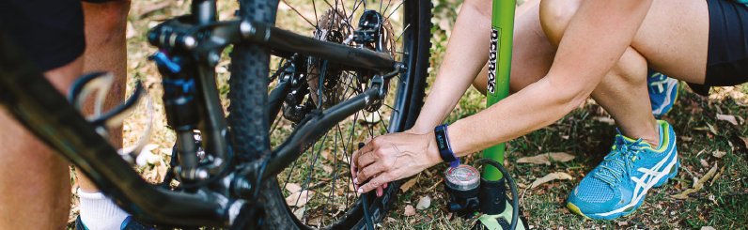

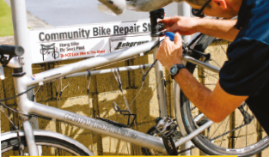

Bicycle Queensland

Bicycle Queensland (BQ) is the leading voice for community cycling in Queensland. With almost 18,000 members state-wide, BQ exist to help Queenslanders ride safely. They are dedicated to the promotion of bike riding as a driving force for individual health and well-being, and the empowerment of sustainable development.

Over the past 40 years, BQ has grown from a small collective of cycling enthusiasts to one of the largest and most influential community cycling organisations in Australia. The organisation encourages people of all ages and abilities to cycle for sport, for fun, to socialize, and to experience our communities and natural environment.

Ultimately, BQ aim to help inspire your love of cycling. As a member, you’ll receive:

- invitations to events and social networking opportunities

- comprehensive global rider insurance

- advocacy on cycling-related issues

- access to legal advice

- nationwide 24/7 Incident Debrief Service

- a free bike service!

Visit bq.org.au or call 3844 1144 to find out more.

Bronwyn’s story

I ride to work from Tarragindi to Gregory Terrace every day via the bikeways, including along South Bank, which is shady and very pretty, through Roma Street Parkland and Victoria Park.

Riding to work every day means there is one less car on the road, so less pollution and less congestion. It is cheaper than driving too.

For me, riding is a great way to keep fit and I get to see the best parts of Brisbane by bike: the river paths, the trails near the creeks and the parklands.

I like being part of the community of people who ride bikes. It is inspirational to see so many people embracing two wheels.

Like to share your story? You can be a guest curator on Cycling Brisbane’s Instagram account. Apply at instagram.com/cyclingbrisbane
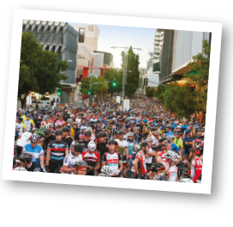
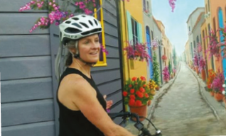

Kids and riding

At Cycling Brisbane, we love encouraging kids to ride a bike. You never forget how to ride a bike – so start them young!

Learn to ride

Cycling Brisbane organises free learn to ride workshops for younger kids (5-10 year olds). Our friendly trainers, who parents have described as ‘miracle workers,’ also prove tips on how to get children riding without training wheels.

For older kids, Cycling Brisbane run activity-based workshops to help them become more skilled and confident with their riding. Brisbane has mountain biking trails and BMX tracks for all ages to enjoy (see page 19 of this guide).

To book your child into a workshop, visit cyclingbrisbane.com.au/events

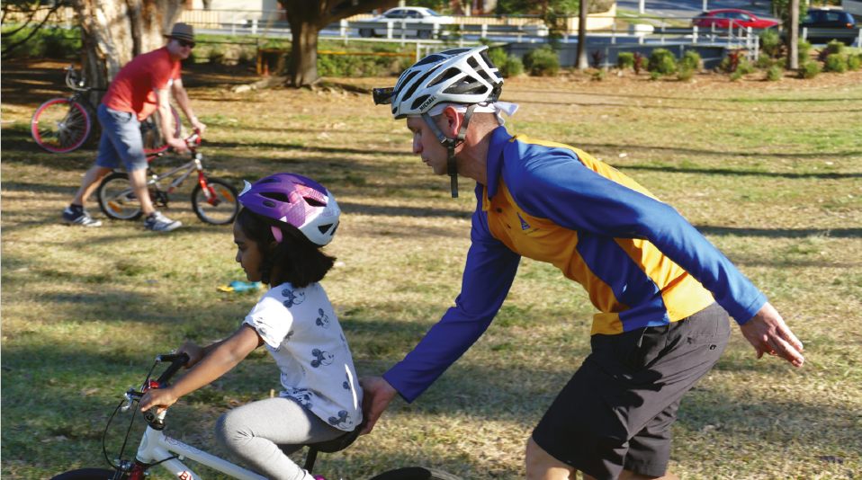

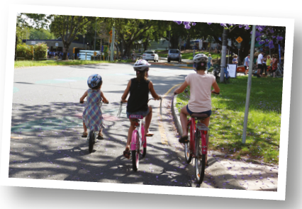

Riding with kids

Brisbane has lots of family-friendly bikeways to enjoy. You can explore routes that travel
along beachside foreshores, parklands, nature reserves and, of course, the Brisbane River.
Try these rides with younger kids:

- The Lake Parklands, Forest Lake:
a scenic 2.2 kilometre bike trail with a waterfall, an abundance of wildlife and a kids’ playground.

- Minnippi Parklands, Carindale:
with smooth, flat pathways, this is a great location to learn to ride.

- Rocks Riverside Park, Seventeen Mile Rocks:
take a ride along the flat 2.6 kilometre bike path and enjoy the riverfront views.

- 7th Brigade Park, Chermside:
this path includes a mini-road layout.

- Riverside Drive, West End:
this road hugs the river and is closed to vehicle traffic between Ferry Road
and Davies Park.

Kids too small to ride their own wheels? There are a variety of ways to carry younger
children on an adult bike, such as a:

- trailer attached to the back of an adult’s bike

- bike seat attached behind the rider’s seat

- bike seat attached in front of the rider’s seat

- cargo bike.

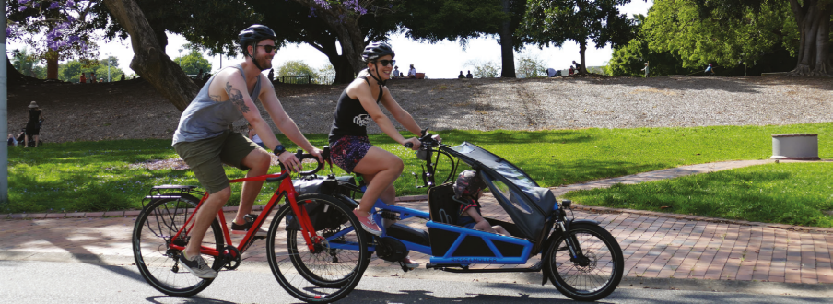
For more information and videos, visit cyclingbrisbane.com.au/bike-rides-try

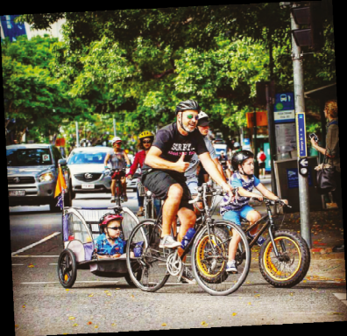

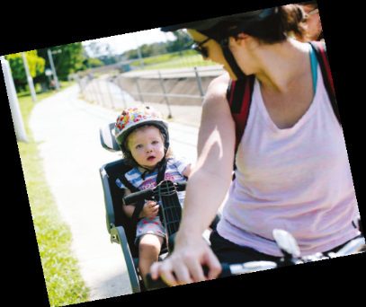
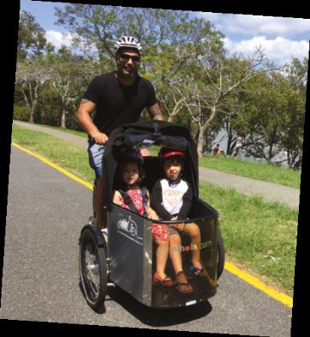

Riding to primary school

Council’s award-winning Active School Travel program runs in primary schools throughout Brisbane and encourages children to ride, walk and scoot to school.

For more information visit brisbane.qld.gov.au and search ‘Active School Travel’.
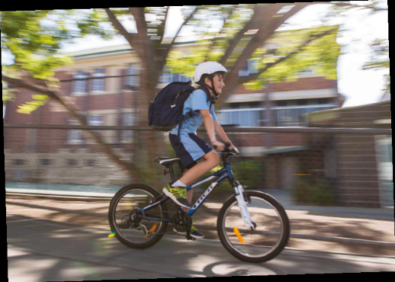

Riding to high school

A number of high schools are located on Brisbane’s bikeway network. Encouraging kids to ride to high school is a great way for them to learn to become more independent, and to maintain good health and wellbeing.

TRACTION’s story

TRACTION’s Bicycle Build program provides the opportunity for young people to get hands-on experience in bike building, repair and maintenance. Participants restore bicycles donated
by the community and bring their own custom designs to life.

We understand that everybody learns differently, and some young people don’t realise their potential in a classroom. Our workshops give them an opportunity to thrive in a different environment where they get to participate in hands-on, action-based education programs.

We use learning to build and fix bikes as a platform for imparting a range of life skills such as taking responsibility and maintaining respectful relationships. As Bailey J, one of our participants, puts it:

“I really enjoy the experience I get at TRACTION, creating things and having fun with the mentors and other students. The feeling from putting a bike together, knowing what you’ve accomplished, is pretty fantastic.”

Find out more at traction.community or follow @tractionbuilds
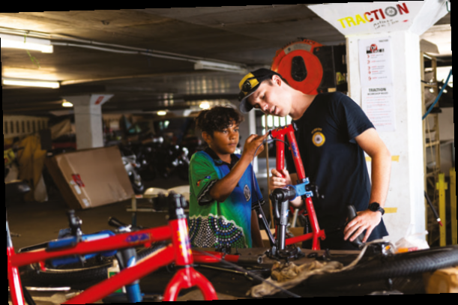

Mountain biking and BMX riding

Mountain biking and BMX riding are two of Australia’s fastest growing recreational activities. Brisbane has plenty of facilities for these popular types of riding.

Mountain biking

It’s a great way to get out and explore some of our region’s bushland areas while keeping fit.
The rules of good mountain biking are simple:

- Ride safely: if you’re riding downhill, give way to riders coming uphill.

- Be prepared: carry a first aid kit and mobile phone, and tell someone where you are going.

- Protect the bush: take only photographs, leave only tyre prints.

South East Queensland has a number of mountain biking areas catering to a range of ages and abilities. Some of the most popular are:

- Bayview Conservation Park

- Bunyaville Regional Park

- Daisy Hill Conservation Park

- Mt Coot-tha Forest

- Redlands Track Park.

For more information about mountain biking, including South East Queensland trail maps, virtual tours and videos, visit cyclingbrisbane.com.au/riding and select ‘mountain biking’.

Council runs a volunteer-based program to look after the trails in Mt Coot-tha Forest. Volunteer mountain bike riders are working in cooperation with Council to protect and restore natural areas by maintaining and improving the track and trail network.

To volunteer visit brisbane.qld.gov.au/ and search ‘Habitat Brisbane’, or call Council on
3403 8888.

Do you want to learn mountain biking skills? To book into a free Cycling Brisbane workshop, visit
cyclingbrisbane.com.au/events
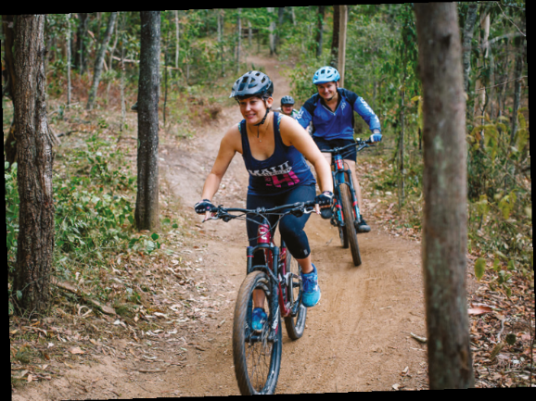

BMX riding

BMX riding is an outdoor sport that the whole family can enjoy. There are many parks across Brisbane that offer BMX facilities for fitness, fun and recreation and cater for different skill levels.

Council has completed state-of-the-art tracks at Bracken Ridge and Darra. You can also ride your BMX bike in some Brisbane skate parks.

For a list of BMX facilities, visit brisbane.qld.gov.au and search ‘BMX parks’.
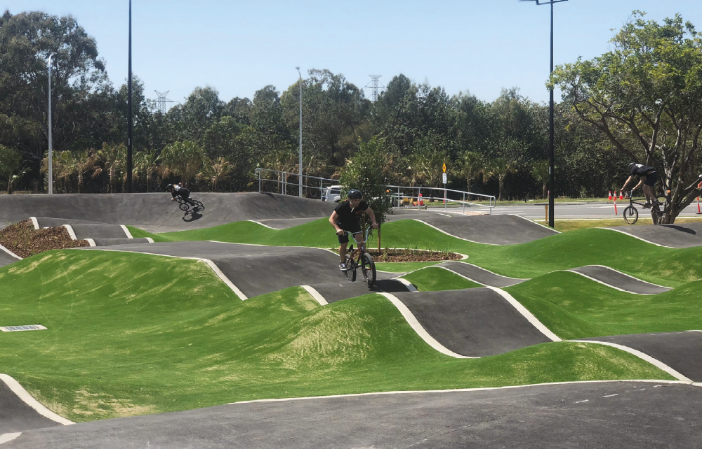

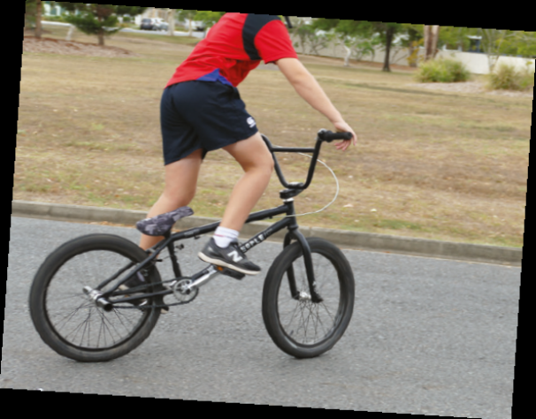

Training Rides

Brisbane has many popular training rides. Here are two of the best loops to try.

Mt Coot-tha loop

The ride begins at the base of Mt Coot-tha on Sir Samuel Griffith Drive. Ride in a clockwise direction for a moderate in-the-saddle climb, or in an anti-clockwise direction for a challenging, leg-burning ascent. The loop is approximately 12 kilometres. Ramp up your hill training with this heart-pumping ride and be rewarded with amazing views at the summit lookout.

Brisbane River loop

This 35-40 kilometre ride includes bikeways and on-road riding in South Brisbane, Brisbane City, Milton, Auchenflower, Toowong, St Lucia, Indooroopilly, Chelmer, Graceville, Tennyson, Yeronga, Dutton Park, Highgate Hill and West End. There are lots of variations to the loop and it can be completed in either direction (generally anti-clockwise for training), with many people beginning and ending the ride at South Bank.

Brisbane Cycling Festival

The annual Brisbane Cycling Festival brings the best of the world’s track cyclists to the Anna Meares Velodrome at Chandler. It also includes competitive road races and mass participation events.

For more information and tickets to the Brisbane Cycling Festival, visit brisbanecyclingfestival.com
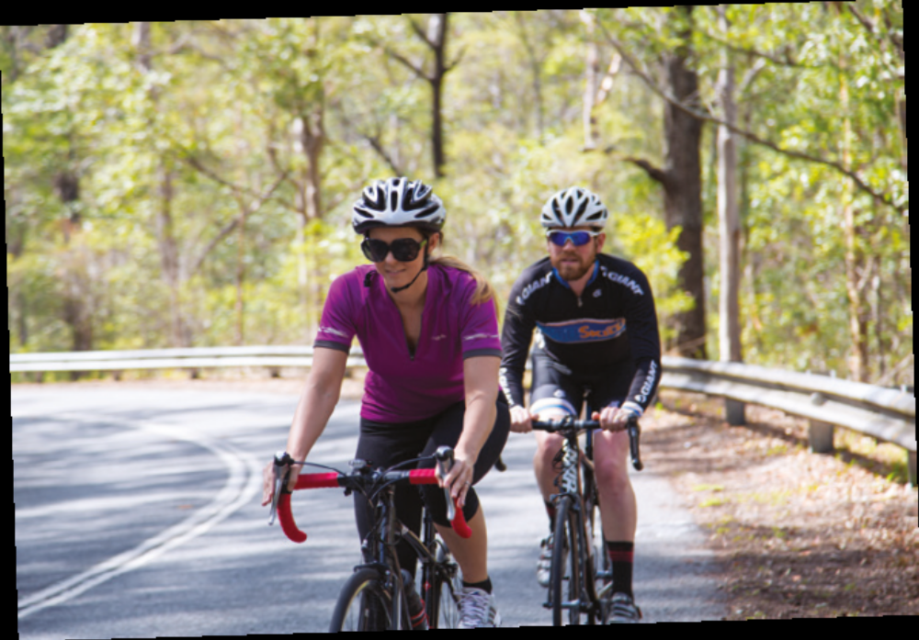

Getting around Brisbane by bike

Know where you want to go? Use this section to find out what to do with your bike once you get there, how you can combine your bike ride with public transport, and tips for carrying things with you when you ride.

Parking and locking your bike

You can park your bike at a variety of public racks across the city.

To use a public bike rack, you’ll need a lock that can fit onto your frame. Cycling Brisbane members can get discounts on bike locks – see back of guide for a list of stores.

All Council libraries and many other community facilities, such as universities, pools and shops, have bike parking racks.

Do you want to suggest a new location for bike parking? Visit brisbane.qld.gov.au and
search ‘bike parking and facilities’ to submit an online form.
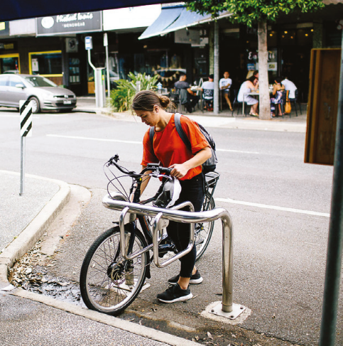
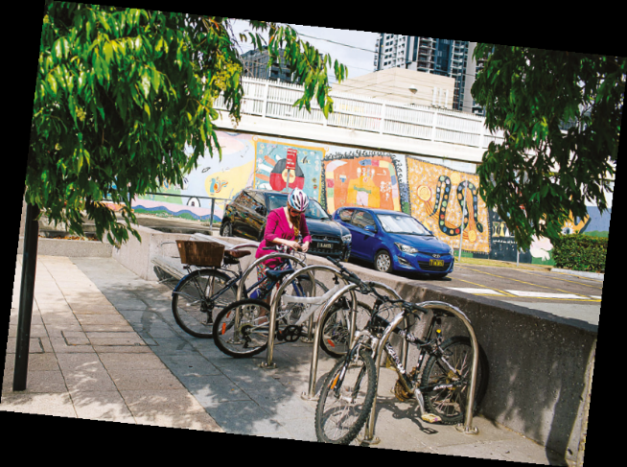

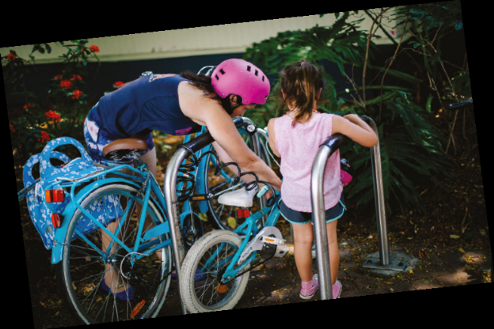

End of trip facilities

End of trip facilities include bike racks, lockers, showers, changing rooms,
and some offer irons, hair dryers and a laundry service!

They have been compulsory for Brisbane’s major new developments, such as office buildings and hospitals, since 2010 and the number of end of trip facilities in Brisbane continues to expand. If you’re not sure whether the building you live, work or study in has end of trip facilities, ask your
building manager or someone you know who already rides.

If you are without an end of trip facility in the city centre, you may wish to become a member of Cycle2City underneath King George Square, which includes secure bike locking, showers and changing rooms. Cycling Brisbane members get an introductory discount – see the back pages of this guide.

To watch the Cycling Brisbane animation about riding to work, visit cyclingbrisbane.com.au/riding-types and click on ‘riding to work or study’

Riding to public transport

Combining a bike ride with public transport can be a very practical way of getting to your destination.

You can ride to your public transport stop, lock your bike, and complete your journey at the other end by walking or using CityCycle if there are bikes located in your area.

Bike parking is provided at most ferry terminals and at all busway stations. Bus interchanges at Westfield Carindale, Westfield Chermside, Westfield Garden City and Mt Ommaney Shopping Centre have secure bike shelters that require an access card.

Queensland Rail has bike lockers and bike racks at many Brisbane train stations, with more than 2500 spaces available.

To search for bike facilities by station, visit translink.com.au

To apply for a bus interchange bike shelter access card, visit brisbane.qld.gov.au and search ‘bike shelter access card’.

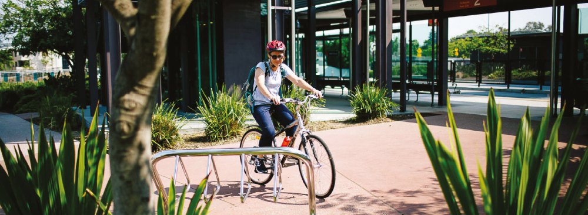

Taking your bike on public transport

You can take your bike on the CityCat and CityFerry provided there is enough space. CityCats have bike racks at the rear of the vessel.

Bikes are allowed on Brisbane trains at all times during weekends and public holidays, and on weekdays excluding:

- 7-9.30am on inbound trains passing through the city centre

- 3-6.30pm on outbound trains passing through the city centre.

Passengers can travel with folding bikes at any time.

Tips for carrying your gear

You can ride with a backpack provided its weight doesn’t affect your balance and control on the bike. Don’t hang bags off your handlebars as it can make your bike unstable and hard to steer.

Alternatively, consider getting a basket or saddlebag. You can also install a rack to attach bike bags called panniers, which are easy to take on and off your bike. The advantage of panniers is that you can carry more weight (and avoid a sweaty back), which makes them a good choice
for local trips and your daily commute.

You can also buy a trailer to attach to a bike, which is ideal for carrying shopping or dogs.

For tips on carrying children on an adult bike, see page 19 of this guide.

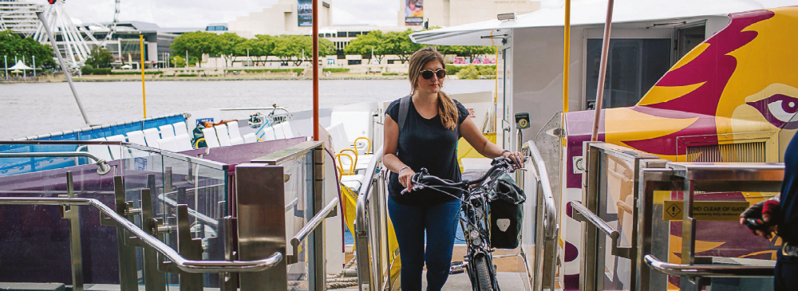

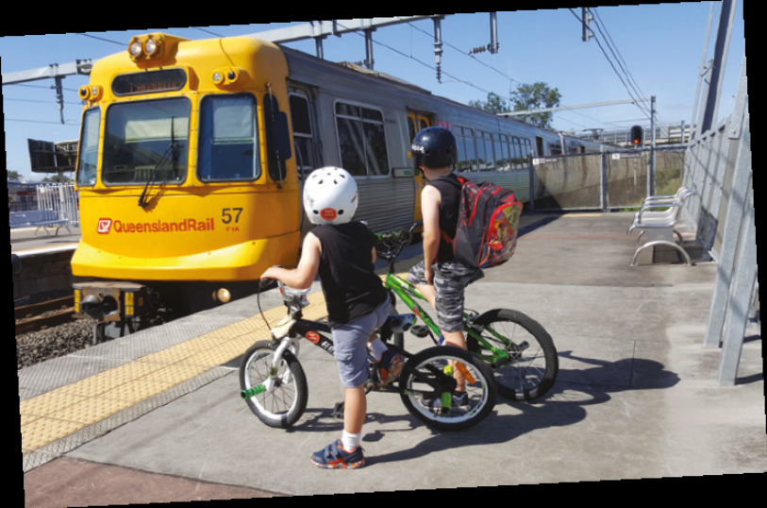

Time to ride?

It’s always a good time to start riding a bike to the shops, work or the train station. But research suggests that a particularly good time to start a new habit is when you’re making a change in your life or when something is changing around you.

Moving house

Find out where the local bikeways are and where they connect to. Check Cycling Brisbane’s online bikeway map or take a look at the maps in this guide.

New job

Ask if your new workplace has a secure place to park your bike and end of trip facilities to change and take a shower.

Starting school

One of the best ways of helping kids be active is to be active with them. Riding, walking or scootering to school is a great way of building this into your daily routine. Visit brisbane.qld.gov.au and search ‘Active School Travel’ for more information.

Starting further education

Studying can be expensive and riding a bike is cheap. Many higher and vocational education facilities are very well located near bikeways.

New local destination

Has a new café, market or playground opened locally? Perhaps the nearby shopping centre has had a makeover. Do local businesses a favour and arrive by bike.

New bikeway

Council is committed to growing the city’s bikeway network. A new bikeway or connection to existing bikeways could make all the difference to you being able to ride to where you need to go. Become a member of Cycling Brisbane to stay up-to-date with the expanding network.
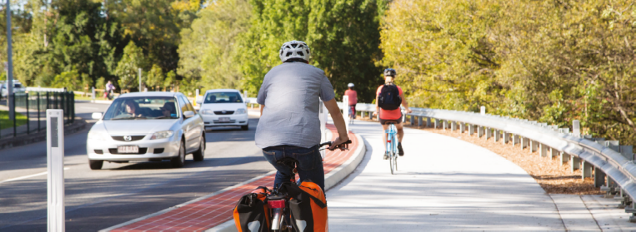

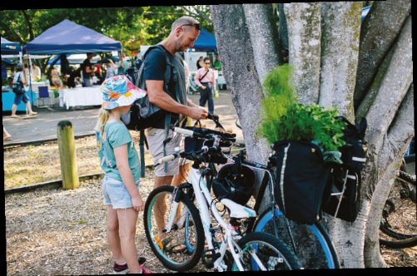

Brisbane’s bikeways

Brisbane’s bikeways are a great way of getting to and from where you are going without the hassles of finding a car park and being stuck in traffic.

Ride around the city

Council is building a bikeway network for the whole city. To keep up with new bikeways and consultations, sign up to Cycling Brisbane (see page 2).

For suggestions about where to ride, visit cyclingbrisbane.com.au/bike-rides-try

Beat the heat

Brisbane summers are hot, so it’s good to know that leafy parts of the city can be more than five degrees cooler than treeless areas, which make them more pleasant places to ride. Bikeways are often located through parks and alongside waterways.

You will find stretches of leafy shade along:

- Bulimba Creek Bikeway (map 13)

- Cabbage Tree Creek Bikeway (map 9)

- Enoggera Creek Bikeway (map 8)

Alternatively, you may want to consider an electric bike (e-bike) to help keep you riding all year round. E-bikes give a power boost provided you are pedalling. They may help you to keep riding through heat and humidity, and over hills.

Try an e-bike at a Cycling Brisbane workshop or event. For more information, visit
cyclingbrisbane.com.au/events
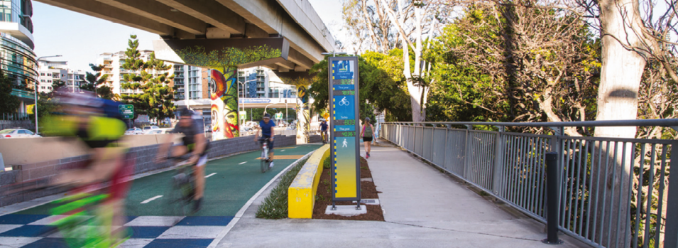
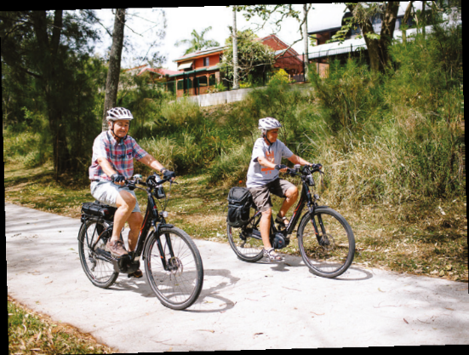

Hire a CityCycle

No bike? No problem! CityCycle has 150 stations available across Brisbane’s city centre, stretching from Newstead to West End and Toowong.

You can buy a $2 casual pass that gives you access to all the distinctive yellow bikes for
24 hours, or sign up as a member. Monthly membership is only $5 ($3 for students).

You can ride all day for free, as long as the bikes are returned within half-hour intervals. A usage fee will apply after this half-hour. You must be over 17 years old to sign up.

You can also link your TransLink go card to your CityCycle account to make using the bikes even easier.

To become a member, or find out where CityCycle share bikes are located, visit citycycle.com.au, or phone 1300 CCYCLE (1300 229 253).
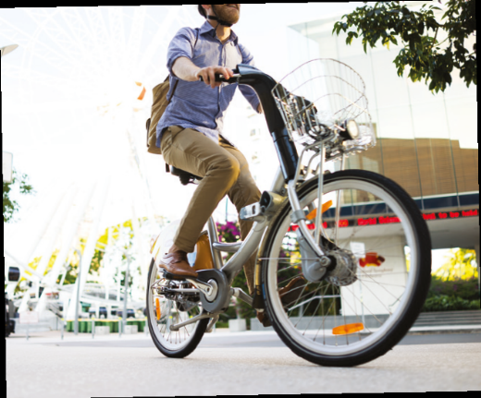

Chris’s story

I was driving our family’s second car five kilometres to the train station each day to get to work in
the city. I thought I’d try riding the bike, which was gathering dust in the garage, to the station instead. It was actually quicker than driving in peak time.

After a few weeks, I upgraded my bike and tried riding the full 15 kilometres to the city from
the western suburbs. I never looked back after that. We sold our second car and saved our
family thousands a year in petrol, registration, insurance, servicing and public transport fares.

I keep riding mostly because it’s fun. I’m not out there to set any speed records but I enjoy the ride, and there’s nothing quite like the sight of the Brisbane River from the Bicentennial Bikeway on a still morning. The only thing better is when a friend catches up and you can have a chat on your way to work. You don’t get that in a car!
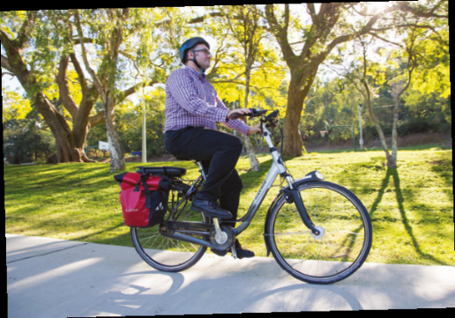

Using Brisbane’s bikeways

Use these simplified maps of some of Brisbane’s bikeway network to see where you can go by bike in the city.

These maps show a selection of the destinations that you can get to by bike, such as bus and train stations, parks, shops and universities. Be inspired to ride somewhere near to you, or find out what other parts of the city you can explore by bike. See the map beside this page for
more information.

These maps are intended to be a guide only. For more detailed information, and journey
planning suggestions, visit cyclingbrisbane.com.au/bikeways

Hamish’s story

When I started a sit-down office job after graduating university, I was restless and gaining weight. My brother bought his first adult bike around that time and it reminded me how much I loved bike
riding as a child.

At first, it was hard. I only had one ride a day in me, relying on the train for the other direction but I stuck with it because even the hottest, sweatiest rides were making me smile.

I now ride my cargo bike to the dog park and to do my weekly food shopping or even taxi my son and partner across to South Bank!

I also make great use of the TransLink app to help me walk, bus, train or CityCat to where I need to go. The car is there for those trips I simply can’t accomplish on public transport.

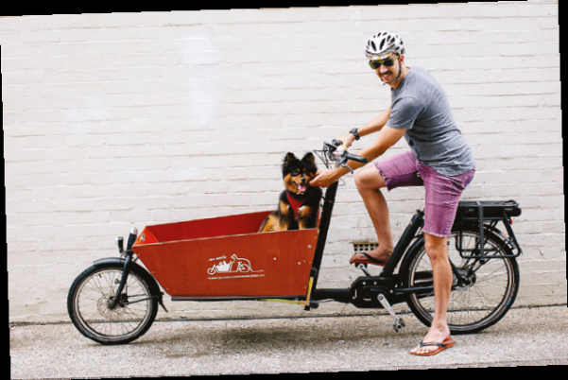

Brisbane’s Bikeways Map

- Inner north to city centre – p30
- Inner south to city centre – p32
- Inner east to city centre – p34
- Inner west to city centre – p36
- Mitchelton to Toombul – p38
- Toombul to Sandgate – p40
- McDowall to Virginia – p42
- McDowall to Bracken Ridge – p44
- Ashgrove to Herston – p46
- Woolloongabba to University of Queensland – p48
- Tarragindi to Norman Park – p50
- Wynnum Manly Foreshore – p51
- Murarrie to Wishart – p52
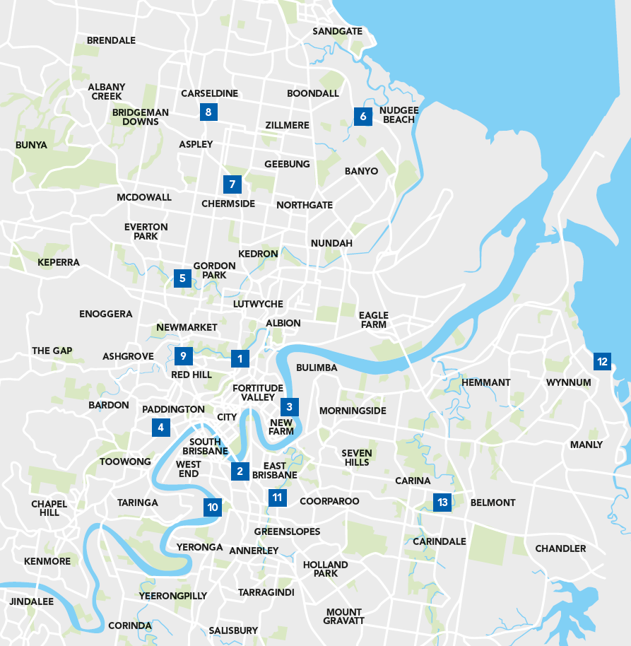

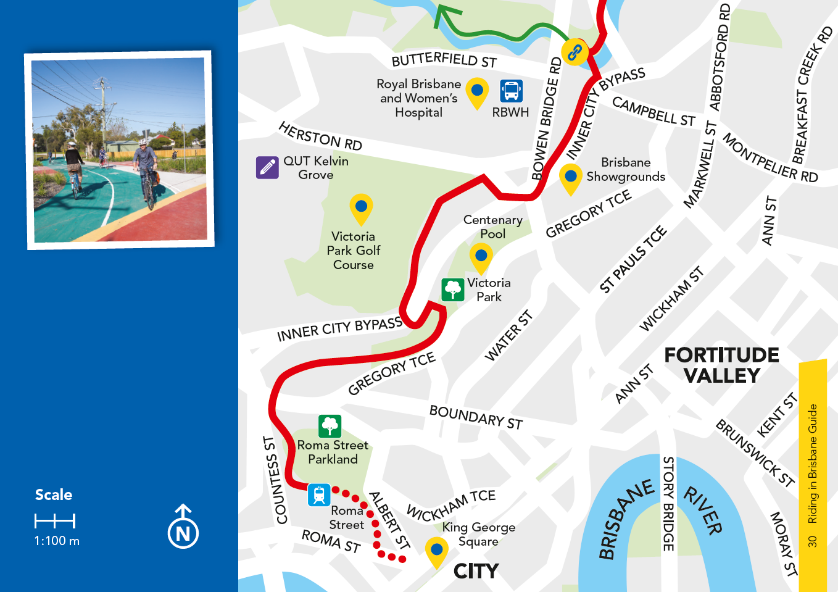

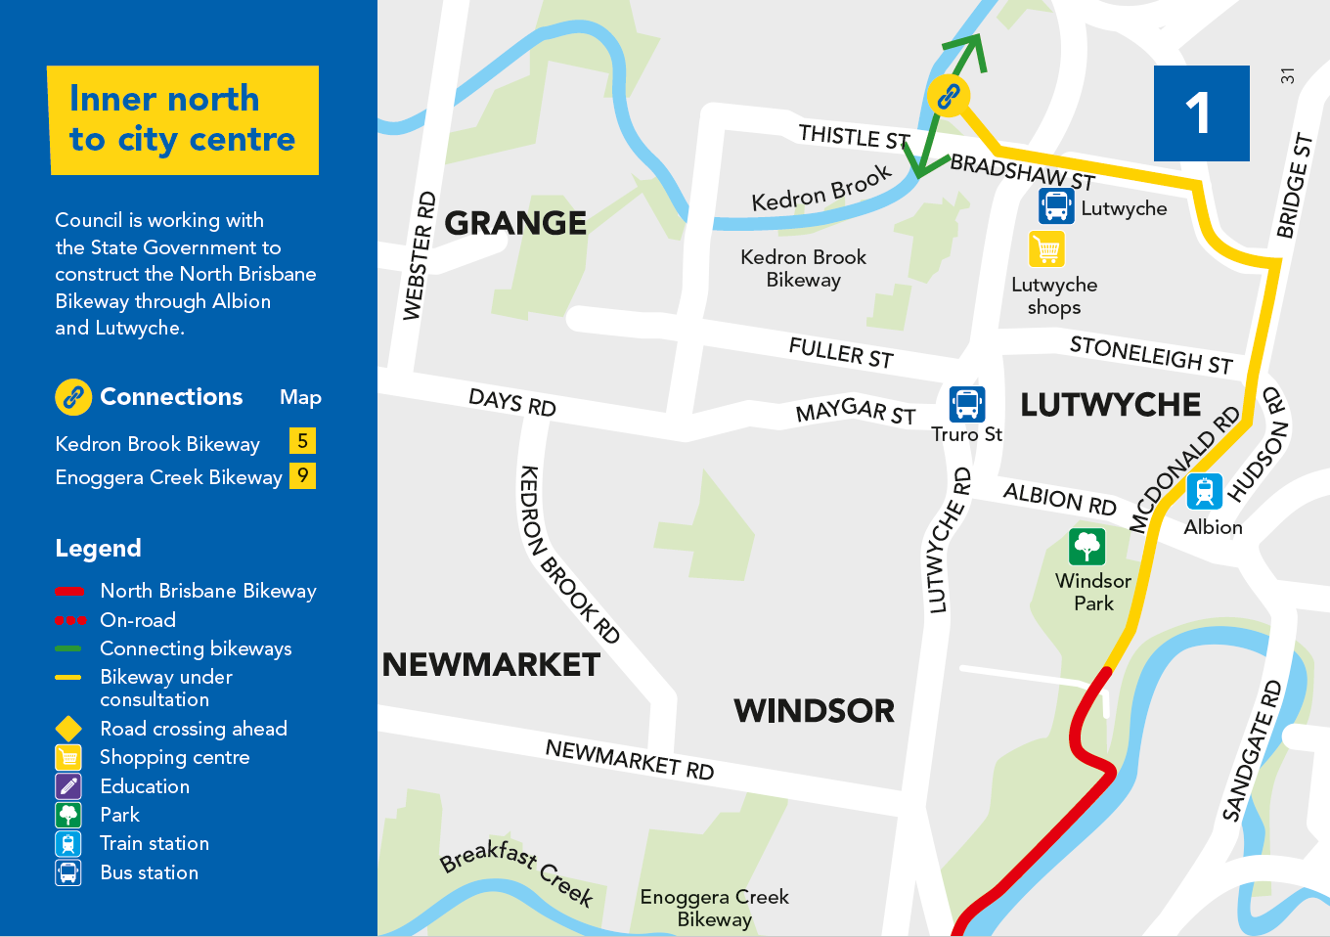

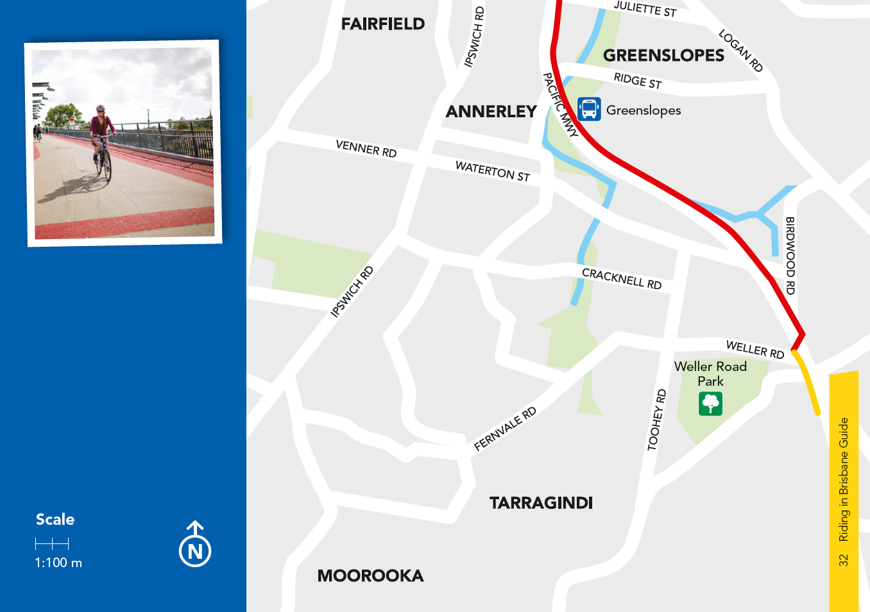

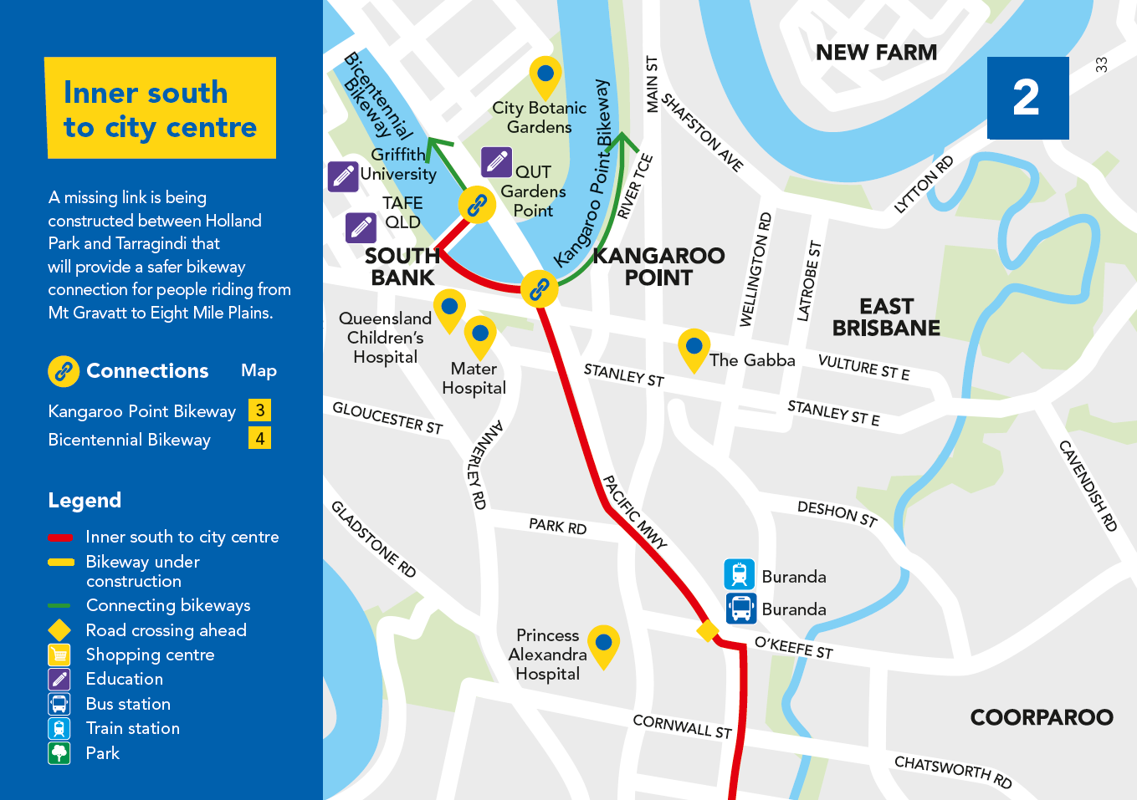

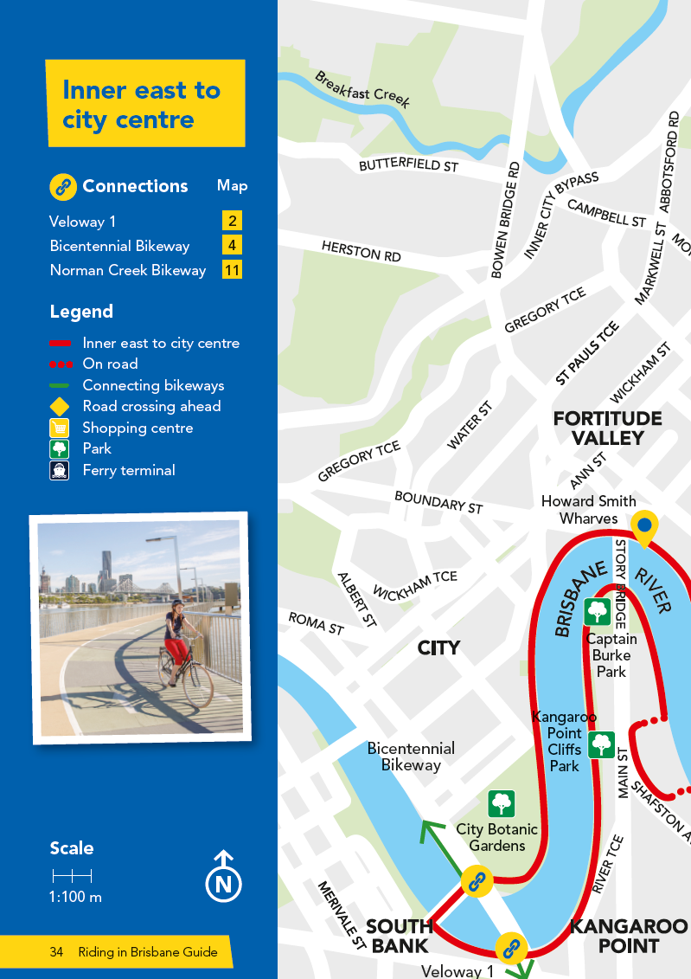

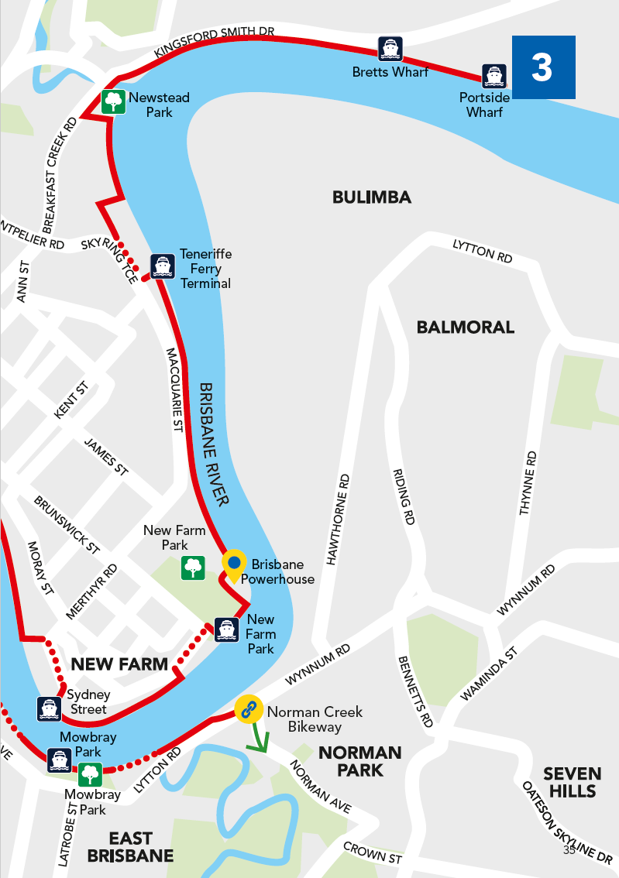

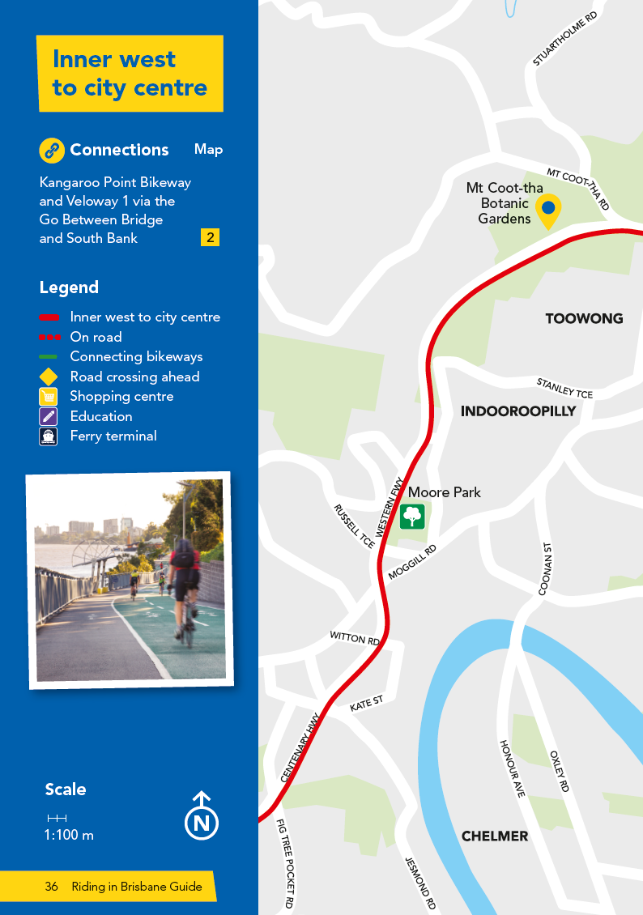

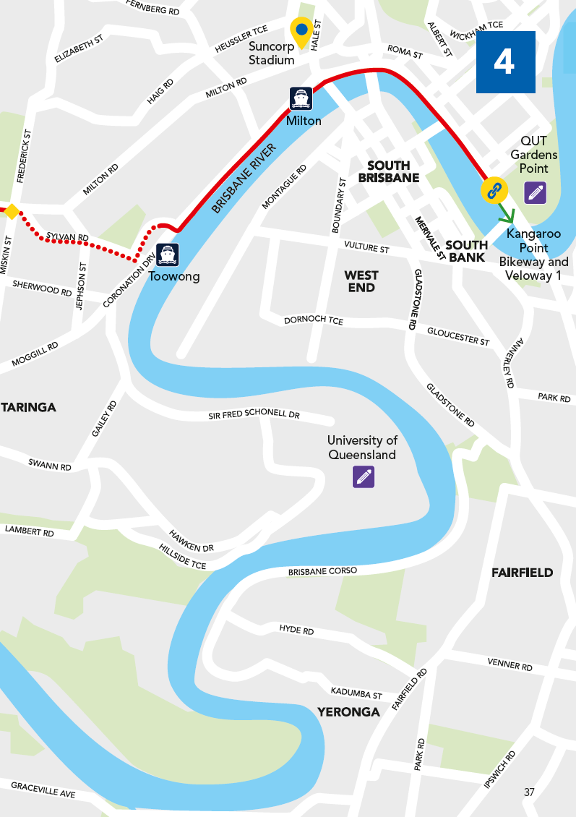

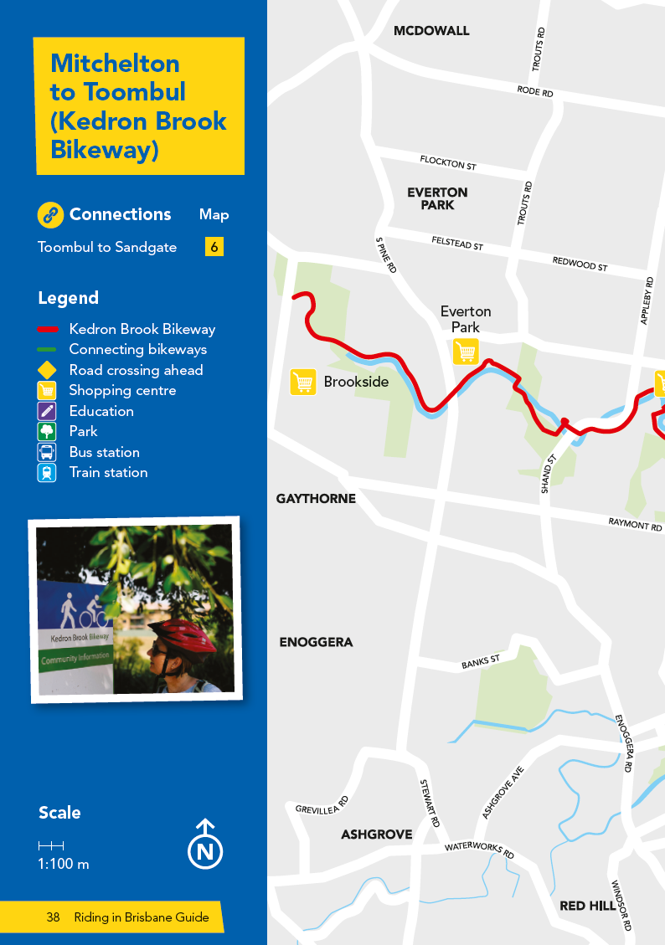

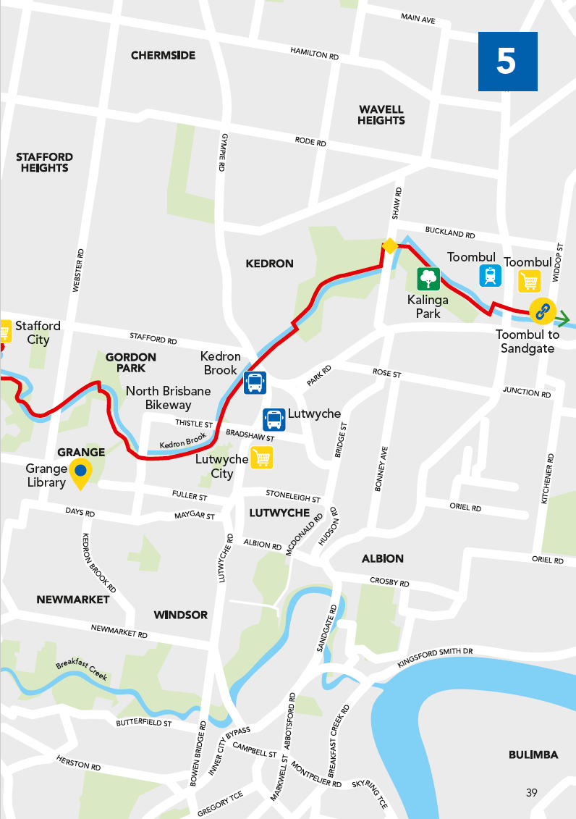

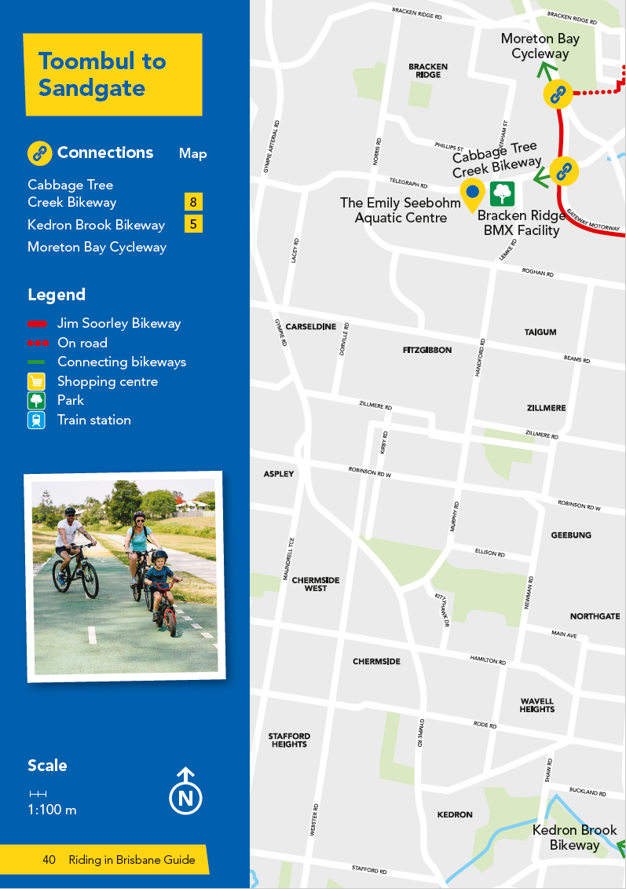

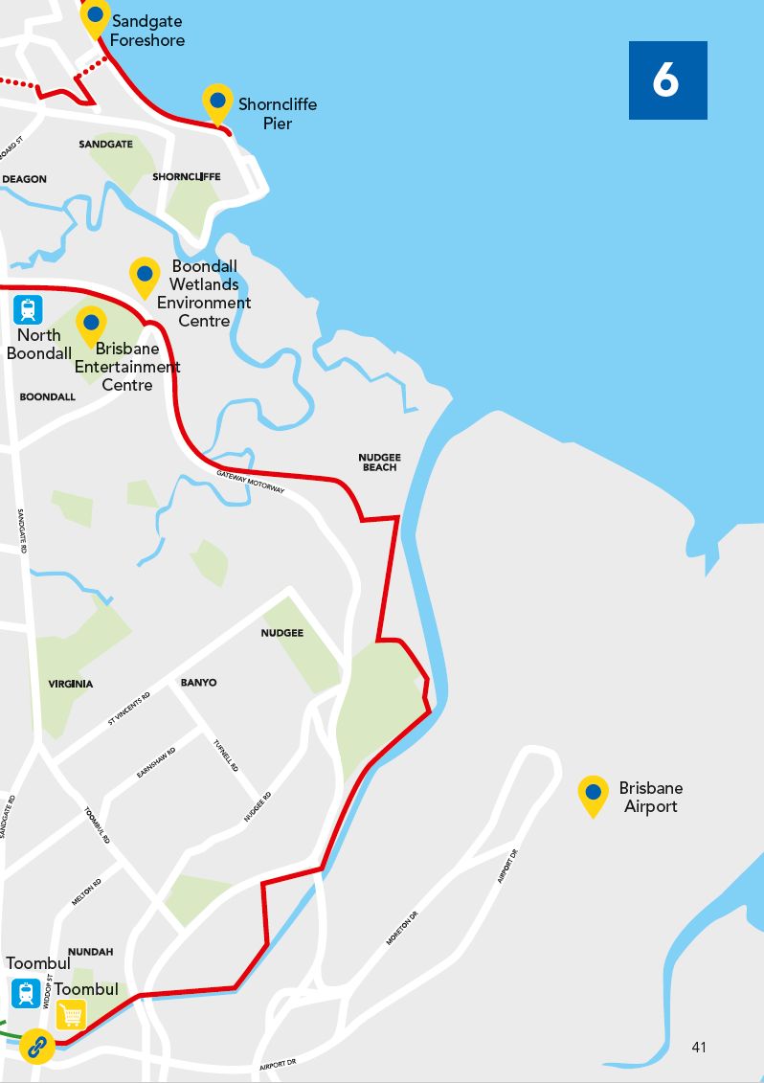

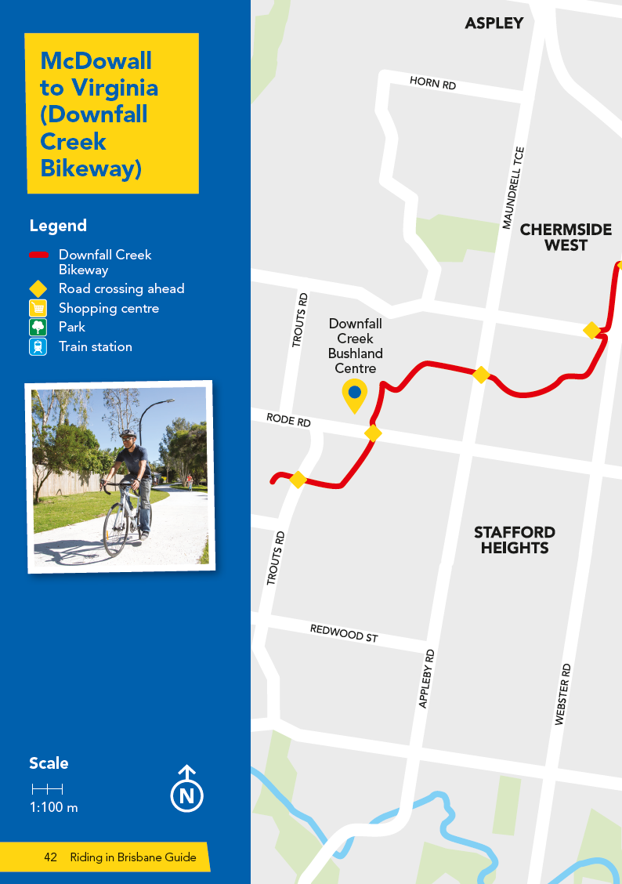

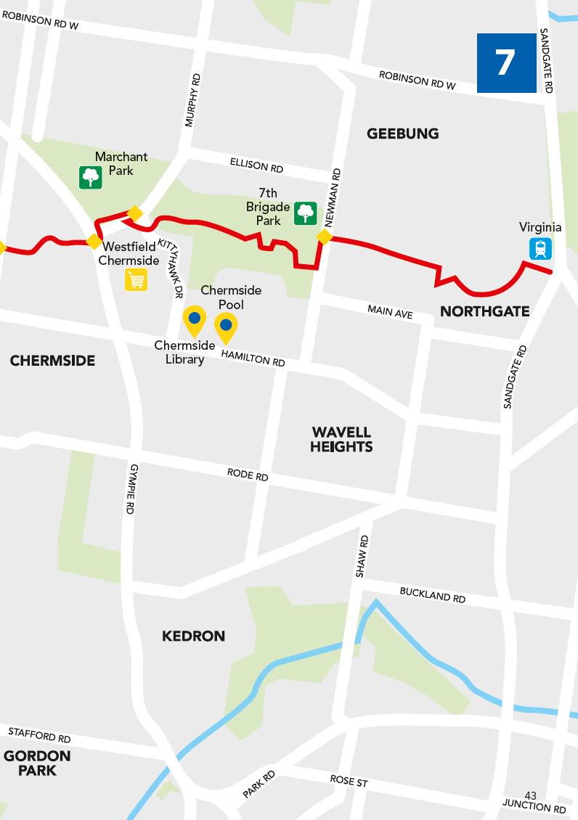

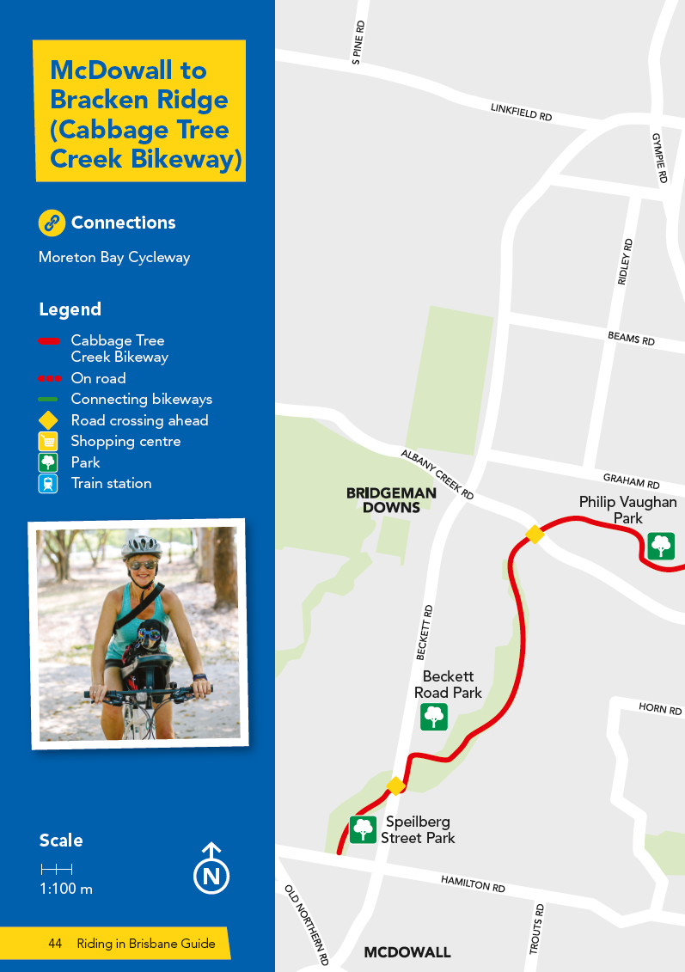

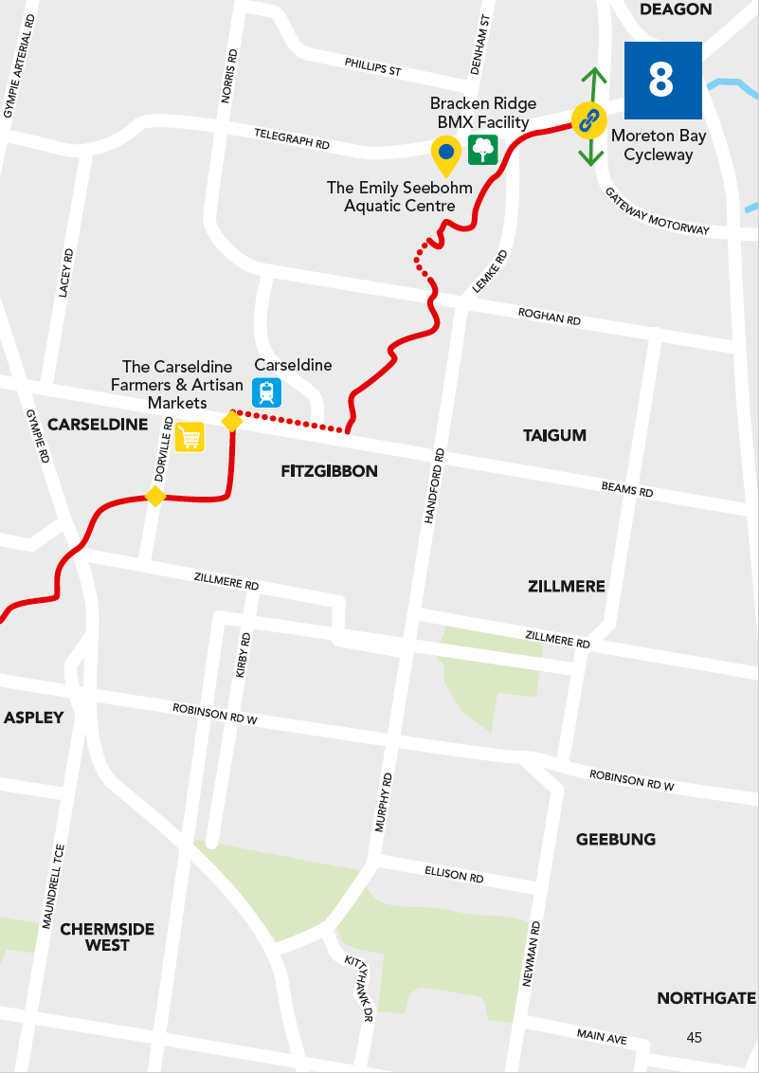

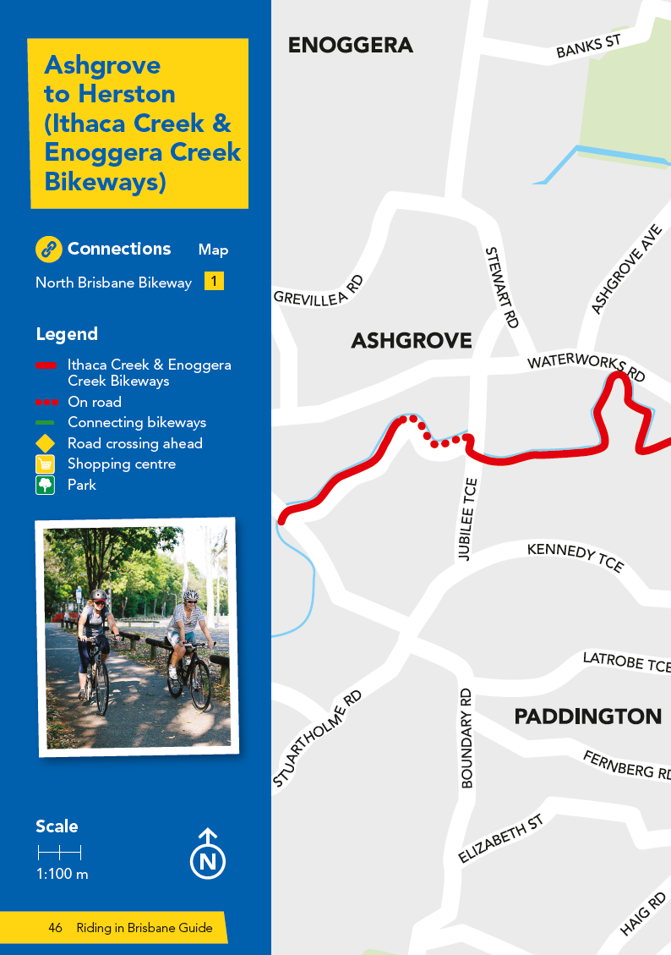

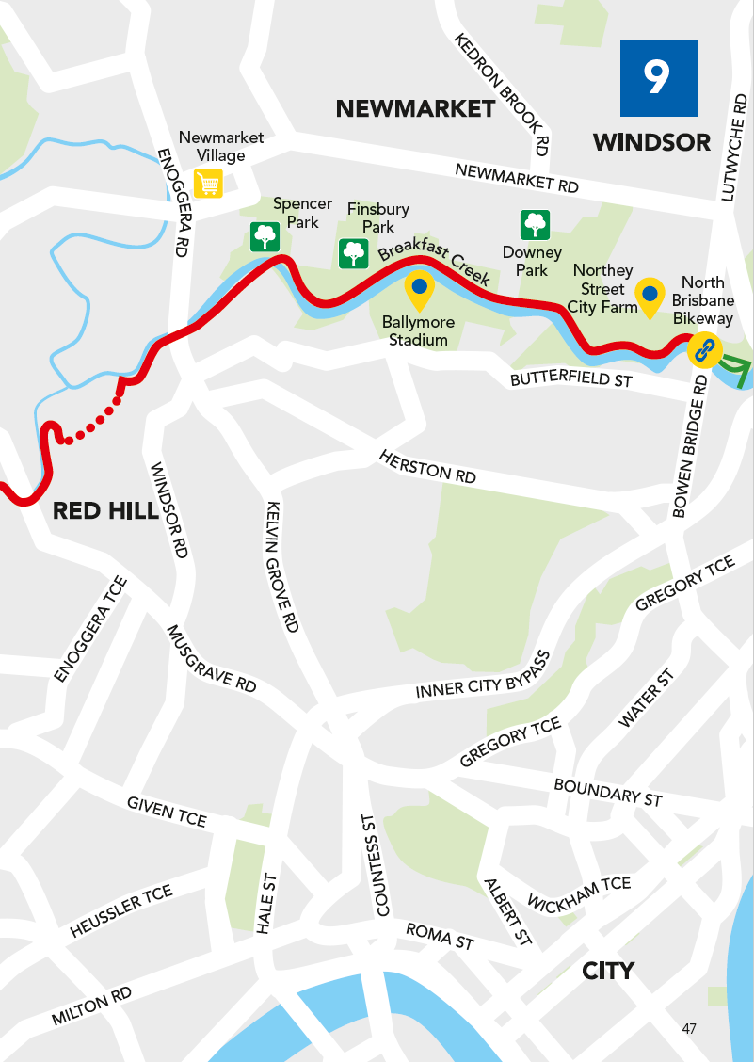

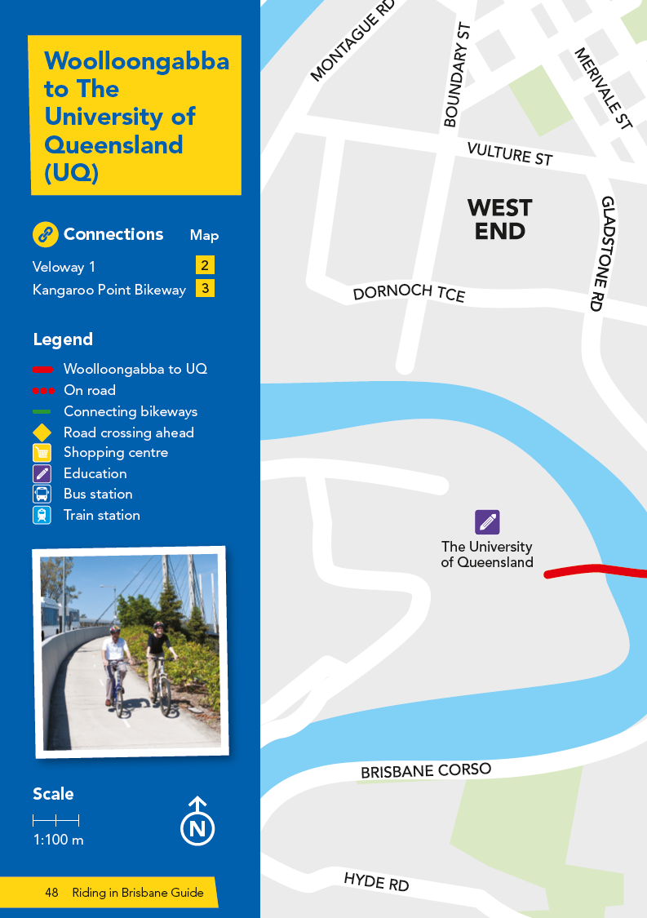

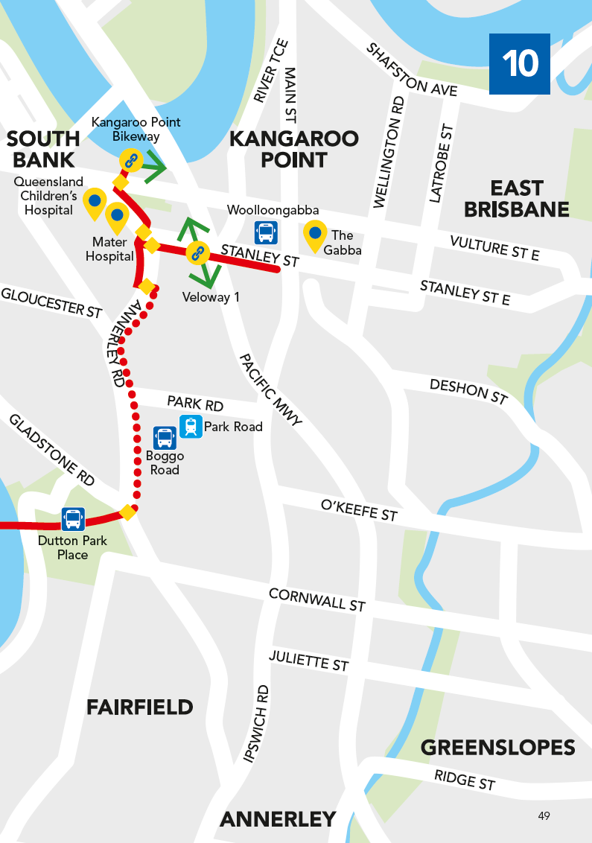

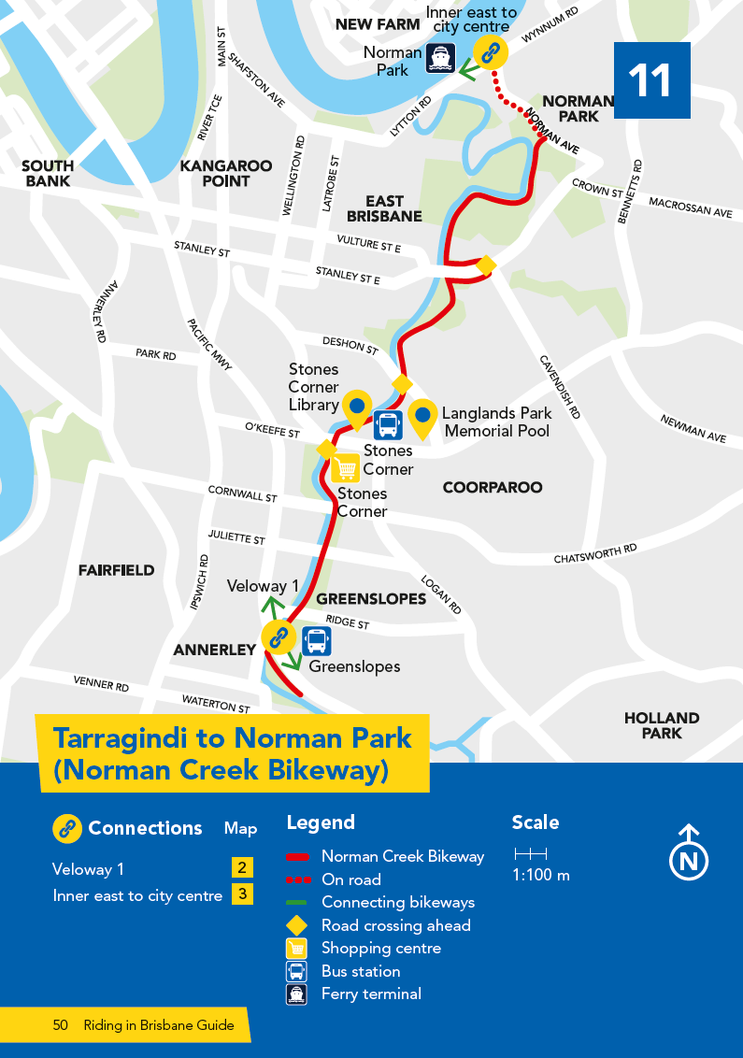

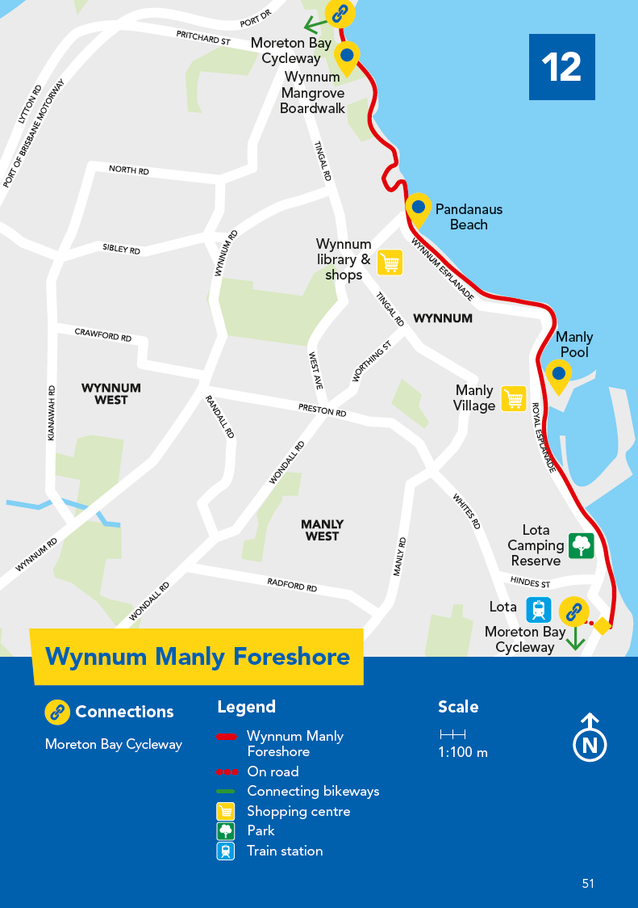

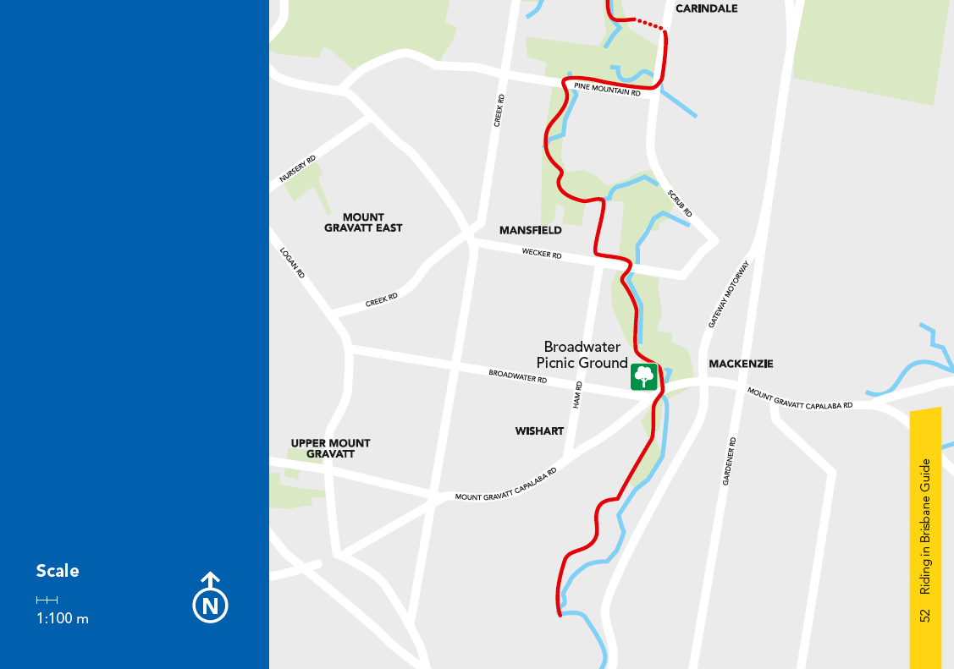

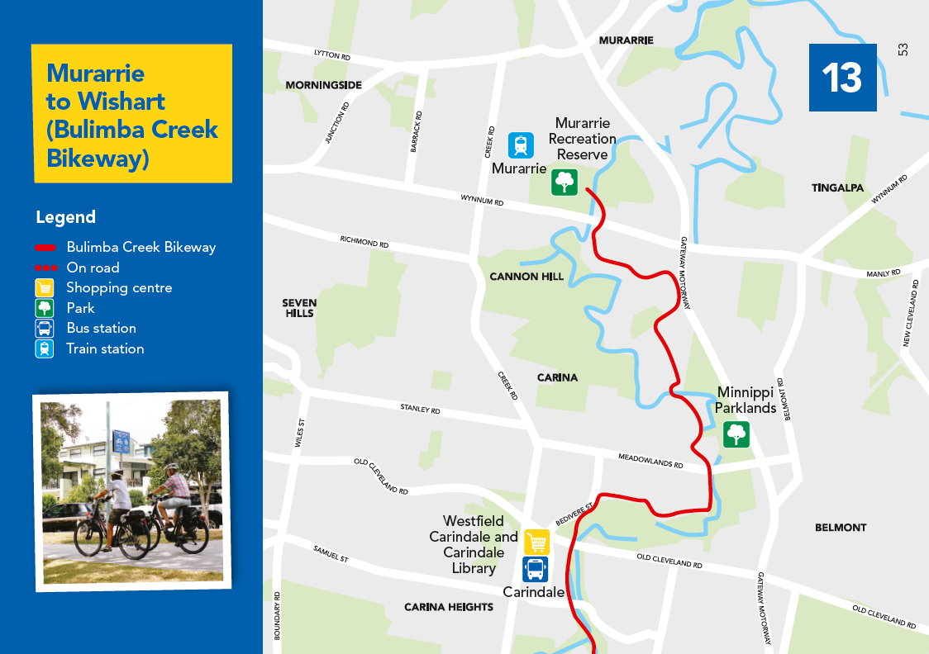

Member deals and discounts

Sign up to Cycling Brisbane for free to start enjoying these great deals and discounts. For more information, terms and conditions, and to redeem these offers, visit cyclingbrisbane.com.au/offers

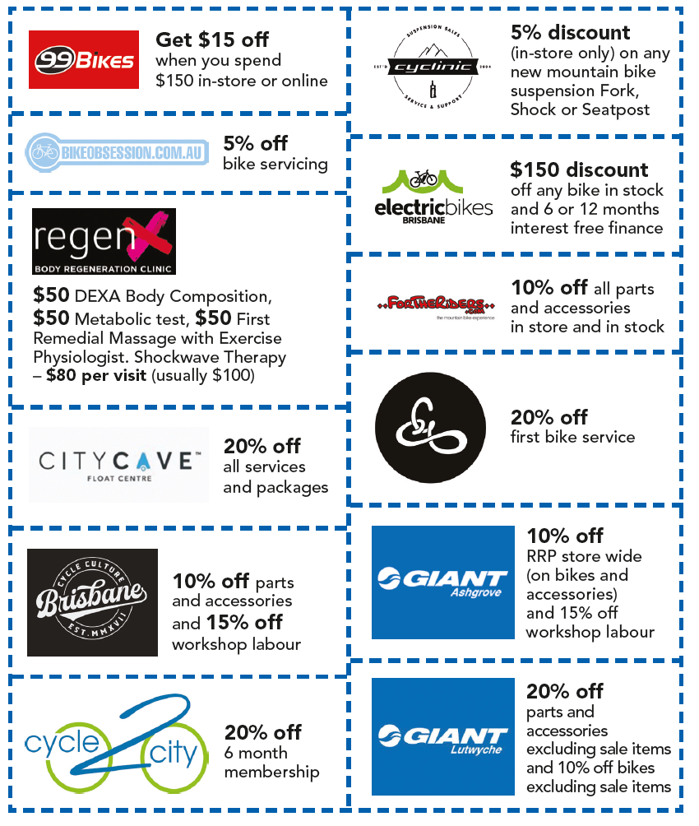

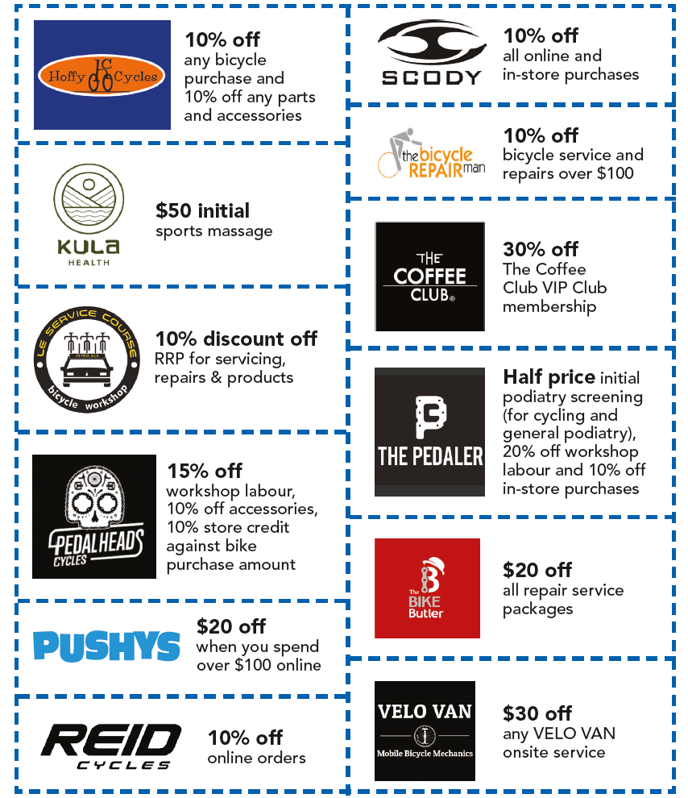

Getting you home quicker and safer.

Share your two wheel adventure @cyclingbrisbane or via #cyclingbne

cyclingbrisbane.com.au

Brisbane City Council
GPO Box 1434
Brisbane QLD 4001

Every effort is made to ensure that information is correct at time of printing

CA19-276916-02-4255
© 2019 Brisbane City Council

Website: brisbane.qld.gov.au
Telephone: 3403 8888

Facebook: /BrisbaneCityCouncil
Twitter: @brisbanecityqld
Instagram: @brisbanecitycouncil

